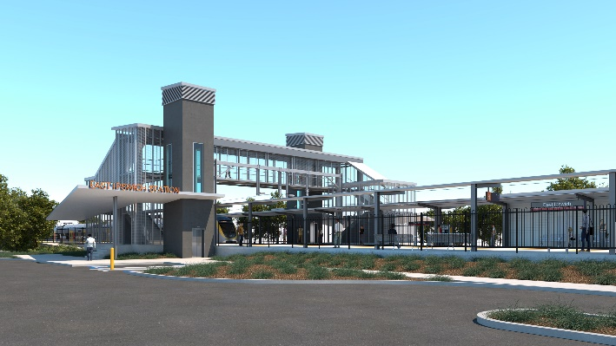
East Ipswich station accessibility upgrade

WORKS NOTICE

Night and weekend works

November 2020

As part of the East Ipswich station accessibility upgrade, Queensland Rail will undertake a two-week period of night works in November 2020. Due to the recent cancellation of a planned weekend (around-the-clock) track closure on the Ipswich line, these works have been rescheduled and can only be undertaken after hours when there are no services operating.
Following this period of night works, critical platform works will be undertaken over the weekend of Saturday 28 and Sunday 29 November, when trains will not stop at East Ipswich station. During this weekend, a shuttle bus will operate between East Ipswich and Ipswich station to connect customers with all services.
We recognise that our works may cause disruption to nearby residents. Every effort will be made to deliver these rescheduled works with minimal disturbance wherever possible. We apologise for any inconvenience as we undertake this critical period of works.
A further two-week block of weeknight works is planned from Monday 7 December – to be notified in more detail closer to the date.
Overview of works
Queensland Rail Limited ABN 71 132 181 090
Location | Dates and hours of work | Type of work
East Ipswich station precinct and rail corridor  Main station carpark (closed)  Rail corridor access gates:  - Merton Street  - Coronation Street | Night works:  9pm to 5am the next day on:  - Monday 16 to Friday 20 November  - Monday 23 to Friday 27 November  (over 5 nights, each week)  Weekend works:  11.30pm Friday 27 to 3am Monday 30 November  (continuous, around-the-clock works) | Station upgrade works involving:  - platform screw piling (drilling)  - installation of structural steel work  - use of hand-held equipment and powered tools (eg. powered socket wrench or ‘rattle gun’)  - excavation, earthworks and construction of retaining walls  - operation of heavy equipment and trucks with flashing lights and reversing beepers  - movement of personnel and vehicles around the station precinct and rail corridor  - traffic management – Coronation and Merton Streets  - use of lighting towers at night.
The East Ipswich station accessibility upgrade is part of Queensland Rail’s program to upgrade stations across the South East Queensland network, making them accessible for all customers. For more information, please contact the project’s community team on free call 1800 722 203 or email stationsupgrade@qr.com.au

