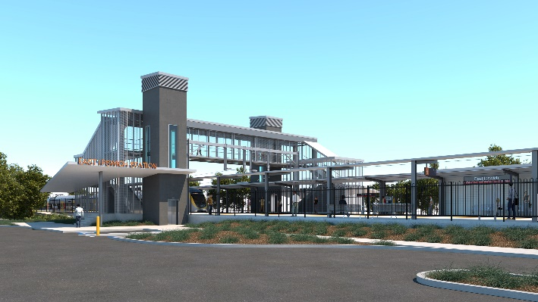
East Ipswich station accessibility upgrade

WORKS NOTICE

Weekend and after hours works

- 2am Saturday 5 to 12.30am Monday 7 September 2020
- Thursday 10 and Tuesday 29 September 2020, 11pm to 4.30am

As part of the East Ipswich station accessibility upgrade, Queensland Rail will undertake continuous works from 2am Saturday 5 to 12.30am Monday 7 September.
On this weekend, for the safety of workers and the public, traffic management will be in operation on-site, with Merton Street closed to traffic at the corner of Woollen Mill Way (Cotton Street). Access to private properties will be maintained at the instruction of the traffic controller. We recommend that resident vehicles be garaged off-street over this weekend.
Following the track closure works, overhead line adjustment activities will be undertaken overnight on Thursday 10 and again on Tuesday 29 September, each of these nights from 11pm to 4.30am the next day.
These works have been planned (weather and construction conditions permitting) during a scheduled track closure and overnight when there are no trains operating and fewer customers around the station precinct.
We recognise that these after hours works may cause disruption to nearby residents, resulting from construction activities in the vicinity of the station precinct and adjacent rail corridor. Queensland Rail has worked closely with the contractor to plan activities and work methodology to minimise disturbance wherever possible and we apologise for any inconvenience as we undertake these important works.
Overview of after hours works
Queensland Rail Limited ABN 71 132 181 090
Location | Dates and hours of work | Type of work
East Ipswich station precinct and rail corridor  Main station carpark (closed)  Rail corridor access gates:  - Merton Street  - Coronation Street  - Bunya Street/Irvine Street.  Road closure (Merton Street, from corner Woollen Mill Way) | During scheduled track closure:  - 2am Saturday 5 to 12.30am Monday 7 September  (around-the-clock works)  Night works:  11pm to 4.30am on:  - Thursday 10 September  - Tuesday 29 September  (overnight works) | Station upgrade works involving:  - track works involving track, sleeper and ballast replacement, formation and soil preparation (earthworks)  - operation of heavy equipment and trucks with flashing lights and reversing beepers  - use of powered tools and hand-held equipment  - movement of personnel and vehicles around the station precinct and rail corridor  - traffic management (road closure) – Saturday 5 and Sunday 6 September.

Novel Coronavirus (COVID-19)

Queensland Rail is committed to keeping essential rail services operating for Queenslanders during this challenging time and to do this, network maintenance and critical capital works must continue. To support workforce safety, Queensland Rail has implemented a number of additional control measures related to COVID-19 management. We will continue to take the necessary precautions to ensure the ongoing health and wellbeing of our team and the communities in which we operate.
The East Ipswich station accessibility upgrade is part of the State Government’s $357 million investment to upgrade stations across the South East Queensland network, making them accessible for all customers.
For more information, please contact the project’s community team on free call 1800 722 203 or email stationsupgrade@qr.com.au

Sign up for paperless notifications at queenslandrail.com.au/EmailNotification

