Milton station refresh
Project update

DECEMBER 2018

Queensland Rail is investing $1.1 million at Milton station, with work commencing in December on CCTV, accessibility and amenity improvements which will be complete by June 2019.

Work will commence to improve the accessibility and security at Milton station in December 2018. It will include enhancing the accessible features of the station, including the ticket booth and amenities, as well as boosting security through the upgrade of 11 CCTV cameras.

Upcoming work
In the coming weeks, customers and members of the local community will see the following activities:
- redevelopment of the existing station building, including the introduction of an accessible ticket window and upgraded public amenities
- installation of new CCTV cameras, hearing aid loop, Emergency Disability Access Phone and Next Train Information device.
- relocation of the office to a temporary site on the overhead walkway.

Customer impacts
Customers and residents near the work site can expect to experience the following impacts:
- noise associated with construction activities
- temporary changes to access paths, including subway and platform closures
- temporary changes to ticket sales, where all ticket purchases and top ups will be made via the ticketing machines (the temporary station office will not be able to accept payments).

Queensland Rail is committed to making improvements to our stations and facilities which allow all customers to travel safely and easily.
These works will improve facilities for all customers, including those with disabilities.
We will keep local residents, customers and community groups informed of our progress.
The station refresh will be complete by June 2019.
Thank you for your patience as we work to improve your network.
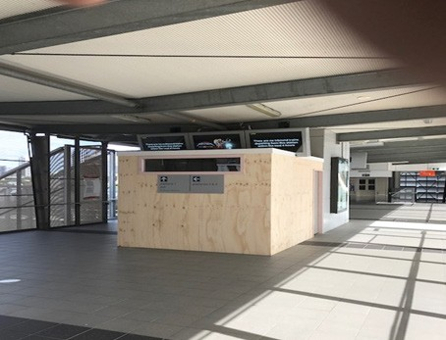

Further information
Phone: 13 16 17 (business hours) Email: customerfeedback@qr.com.au

Post: GPO Box 1429, Brisbane, QLD 4000
Website: queenslandrail.com.au

Queensland Rail Limited ABN 71 132 181 090 QR2018

