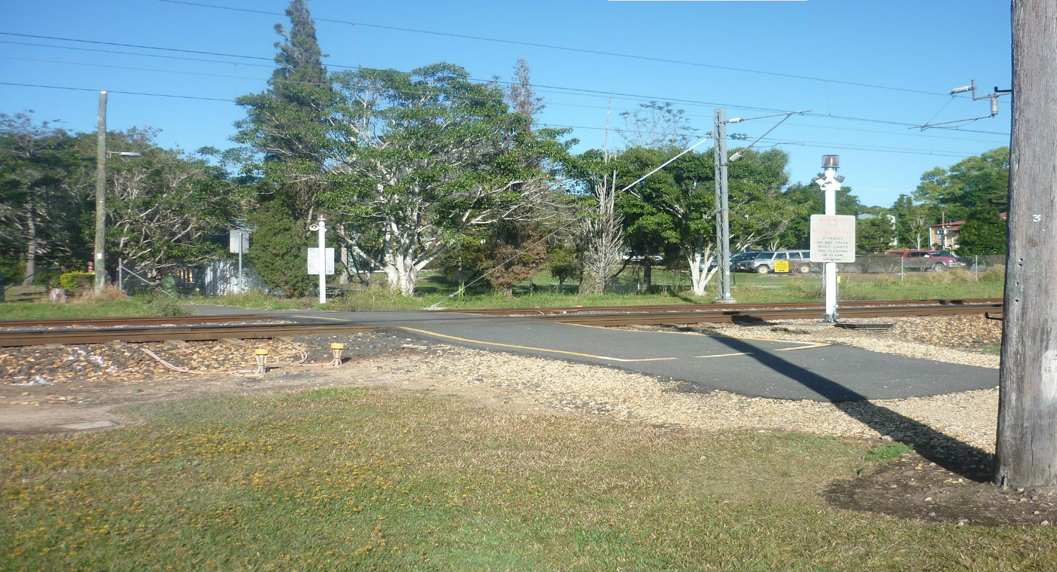Queensland Rail is committed to retaining and upgrading the existing pedestrian crossing, just north of Pomona station. We have listened to the local community’s feedback and understand the crossing’s historical significance to the town and its role in promoting walkability.
Pomona pedestrian crossing upgrade
PROJECT UPDATE – OCTOBER 2018
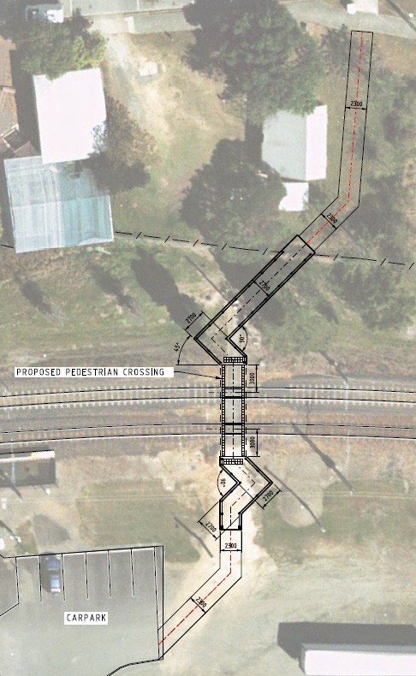The upgrade will ensure the crossing is suitable for the community and compliant with national safety standards. Improvements to the Pomona pedestrian crossing will include:
Station Street
Pomona station
- Replacing the existing flashing light with a pedestrian signal
- Adding a new flashing sign to alert pedestrians when another train is coming, should a train be stopped at the station
- Introducing a pedestrian maze (gates are not included), designed to cater for horse riders, mobility scooters and cyclists
- Signage to instruct horse and bicycle riders to dismount prior to crossing and a height gauge to ensure rider safety
- New concrete path connections on both sides connecting to the station carpark on the east and Station Street on the west
- Lighting along the new path connection from Station Street and up to the station carpark
- Fencing on both sides of the crossing.
Works to upgrade the pedestrian crossing will occur progressively in 2019. During works, there may be short closures to the pedestrian crossing, with pedestrians being directed to use alternative crossings for their safety.
Queensland Rail is interested in hearing the community’s feedback about the design for the Pomona pedestrian crossing.
Feedback can be provided via: phone: 13 16 17

email: communityengagement@qr.com.au
post: Stakeholder Engagement Team GPO Box 1429
Brisbane QLD 4001

