**Shorncliffe station precinct heritage restoration**

**Vegetation**

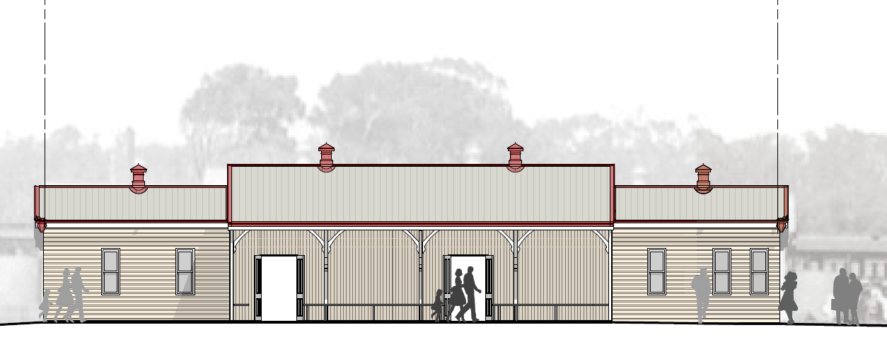

***Artist’s impression – design subject to change***

A vegetation report prepared for the Shorncliffe station precinct heritage restoration has identified some trees which require removal due to their proximity to existing heritage buildings and impingement on the station footprint.

**Significance of flora and fauna**

Queensland Rail recognises the importance of flora and fauna to local environments, and their importance to the community.

To ensure minimal impact on vegetation during the project, Queensland Rail commissioned a vegetation study which assessed trees and other plants on the site.

This study identified a heritage significant small-leaved fig tree at the eastern end of the station. This fig tree serves as an historic landmark and a great source of town pride, and currently holds significant preservation interest. This fig tree will not be removed and is protected under the station upgrade plans.

*Above: Heritage significant small-leaved fig tree at eastern end of the platform.*

No fauna scratches are present on trees at the station nor are there significant habitat trees. The project is not situated within mapped koala habitat.

The study also confirmed that no vegetation protected under the *Queensland Nature Conservation Act 1992*, or the *Commonwealth Environmental Protection and Biodiversity Conservation Act 1999*, will be impacted by the project.

**Removal of camphor laurel tree**

A camphor laurel tree growing close to the heritage-listed air raid shelter has been identified for removal. These types of trees have been classified as being an invasive weed species and the decision to remove this one has been made for the following reasons:

* Close proximity to the adjacent heritage concrete air raid shelter, causing structural damage to its roof and platform surface
* Close proximity to overhead electrical structures requiring ongoing safety clearances that will expose the tree to pest and fungal infections and reduced structural soundness, thereby making it a safety risk.
* Classification as a weed under the *Land Protection (Pest and Stock Route Management) Act 2002 (Qld).*

**Have your say: timber legacy item**

Queensland Rail would like to work with a local community group to turn the timber from the camphor laurel tree into a legacy item for the station. We are looking for your feedback on what form that legacy takes. Some ideas include:

* Timber seating
* Frame for a photo wall or storyboard.

Other ideas are welcomed. Feedback can be provided at the drop off box located at the station ticket office, via the Queensland Rail website ([www.queenslandrail.com.au](https://www.queenslandrail.com.au/)) or via email to [communityengagement@qr.com.au](mailto:communityengagement@qr.com.au).

**Removal of Poinciana tree**

A Poinciana tree which overgrows a portion of the heritage station structure has been identified for removal. This tree requires removal for the following reasons:

* Close proximity of the tree to the roof impeding the safe removal of asbestos sheeting
* Close proximity of the tree to the roof of the heritage station building, restricting access for long-term maintenance and potential damage to the restored station roof
* The necessary removal of tree limbs will cause the tree to become unbalanced posing a safety risk to station users
* The tree is located where a ramp must be constructed to meet station accessibility requirements.

Following the restoration of Shorncliffe station, other suitable mature species will be planted to fit with the historical station aesthetics and surrounding local environment.

**Landscape plan**

The plan below shows the location of landscaping to be completed at the station precinct. Mature trees will be planted outside the train crew facility as well as in other locations across the precinct. Tree species to be planted will be identified during the early stages of construction.

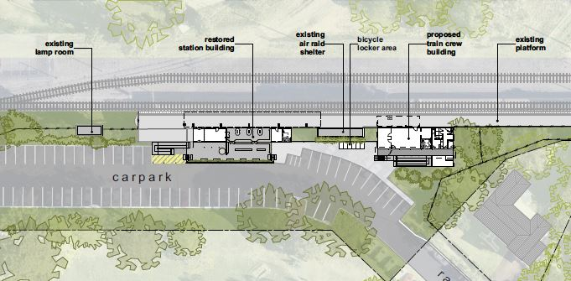

**Keeping you informed**

Queensland Rail is committed to keeping stakeholders and the community informed about this project. For more information, please call **13 16 17** between 8am and 5pm Monday to Friday or email **communityengagement@qr.com.au**.