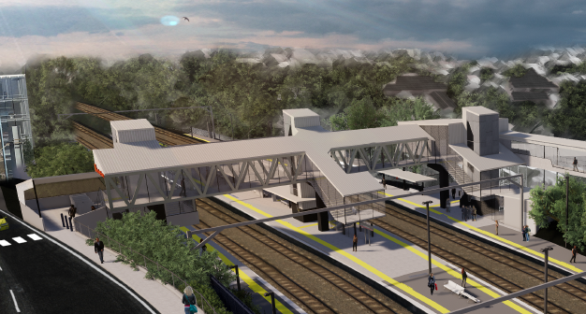

**Auchenflower station accessibility upgrade**

**PROJECT UPDATE – JULY 2020**

**The Auchenflower station accessibility upgrade is part of the State Government’s $357 million investment to upgrade stations across the South East Queensland network, making them accessible for all customers.**

**Project progress**

The following activities have been undertaken recently at Auchenflower:

* completion of Queensland Rail’s early works – overhead infrastructure and track activities
* tender award and contractor appointment
* ongoing station upgrade design.

**Upcoming works**

In the coming weeks, customers and community can expect to see the following activities:

* geotechnical investigations
* site establishment
* removal of existing waiting shelters, installation of temporary shelters and relocation of ticketing equipment and platform furniture
* tree removal (adjacent to platform 4) and closure of Auchenflower Terrace – see below.

**Tree removal and road closure – Auchenflower Terrace**

The station upgrade has been designed with consideration given to the impact on local trees.

To deliver the upgrade, it will be necessary to remove some trees around the station precinct, adjacent to Auchenflower Terrace.

This will enable the safe construction of the station’s new footbridge, lifts and walkway connecting the new lifts with the station’s carpark.

Removal of trees is expected to take place during the planned weekend track closure on 1 and 2 August and will involve the closure of Auchenflower Terrace between McIlwraith Street and Ridley Street. Access to private properties will be maintained at the instruction of the traffic controllers.

Tree removal will be carried out under an approved Environmental Management Plan and a fauna spotter/catcher will be engaged prior to any works.

The project will revegetate the upgraded precinct with appropriate native species, considering visual amenity and screening of nearby properties.

# 



# Construction impacts

# During works, construction activities may involve:

* changed parking and traffic conditions for safety
* noise associated with heavy machinery
* temporary changes to access paths throughout the station precinct and surrounding areas
* increased vehicle movements near works
* mobile lighting towers for night works.

# Normal working hours are 6.30am to 6.30pm, Monday to Saturday.

# The local community will be given advance notification of construction activities likely to cause impacts, including after hours work (nights, Sundays and public holidays, if required).

# Thank you for your patience and cooperation as we build you a better Auchenflower station.

# Contact us

# For more information, to provide feedback or to be added to the project’s opt-in distribution list for email updates:

# Phone: 1800 722 203 (free call)

# Email: stationsupgrade@qr.com.au

# Website: queenslandrail.com.au