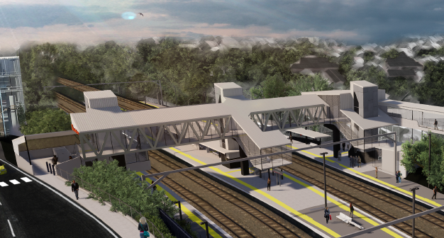
Auchenflower station accessibility upgrade

WORKS NOTICE

After hours works, including tree removal and road closure
Saturday 1 and Sunday 2 August

As part of the Auchenflower station accessibility upgrade, Queensland Rail will undertake after hours works, including the demolition of shelter structures and tree removal, over the weekend of Saturday 1 and Sunday 2 August (weather and construction conditions permitting). These works have been scheduled during a planned track closure, when there are no trains running and the power to the overhead lines can be switched off.
During this weekend, Auchenflower Terrace will be closed between McIlwraith Street and Ridley Street (see map over the page). Traffic management, including a diversion, will be in operation and we ask motorists to drive to the changed conditions. Local access will be maintained at the instruction of the traffic controller.
Tree removal, adjacent to platform 4 (Auchenflower Terrace) will be undertaken to enable the construction of the new footbridge, lifts and walkway to the station’s existing carpark. All tree removal will be carried out under an approved Environmental Management Plan and a fauna spotter/catcher will be engaged prior to any clearing activities. At project completion, the upgraded precinct will be revegetated with appropriate native species, with consideration given to rail operations, visual amenity and screening of nearby properties.
Residents near the station may experience some noise associated with these activities. Every effort will be made to minimise disruption and we apologise for any inconvenience as we undertake these important works.

Overview of works
Queensland Rail Limited ABN 71 132 181 090
Location | Dates and hours of work | Type of work
Auchenflower station and rail corridor  Auchenflower Terrace (road closure, Saturday 1 and Sunday 2 August)  Lang Parade (lane closure, near Wesley Hospital carpark – overnight) | Weekend works during track closure:  - 6am Saturday 1 to 10pm Sunday 2 August  (continuous works)  Road closure, Auchenflower Terrace:  - 6am Saturday 1 to 6pm Sunday 2 August  (continuous road closure)  Night works, Lang Parade:  9pm to 6am the next day on:  - Saturday 1 August  (overnight works) | Station upgrade construction enabling works involving:  - demolition of existing waiting shelters  - operation of a large crane, trucks and machinery with flashing lights and reversing beepers  - tree removal (adjacent to platform 4)  - hand-held tools and powered equipment  - movement of personnel and vehicles around the station and in the rail corridor  - road closure with traffic management – Auchenflower Terrace  - lane closure with traffic management – Lang Parade  - portable lighting towers in use at night.
Novel Coronavirus (COVID-19) – Queensland Rail is committed to keeping essential rail services operating for Queenslanders during this challenging time and to do this, network maintenance and critical capital works must continue. To support workforce safety, Queensland Rail has implemented a number of additional control measures related to COVID-19 management. We will continue to take the necessary precautions to ensure the ongoing health and wellbeing of our team and the communities in which we operate.
The Auchenflower station accessibility upgrade is part of the State Government’s $357 million investment to upgrade stations across the South East Queensland network, making them accessible for all customers. For more information, please contact the project’s community team on free call 1800 722 203 or email stationsupgrade@qr.com.au

Sign up at queenslandrail.com.au/EmailNotification or contact us if you prefer to receive paper copies.

Page 2

Road/lane closures and traffic management

- Road closure, Auchenflower Terrace – 6am Saturday 1 to 6pm Sunday 2 August
- Lane closure, Lang Parade – Saturday 1 August, 9pm to 6am the next day (overnight)

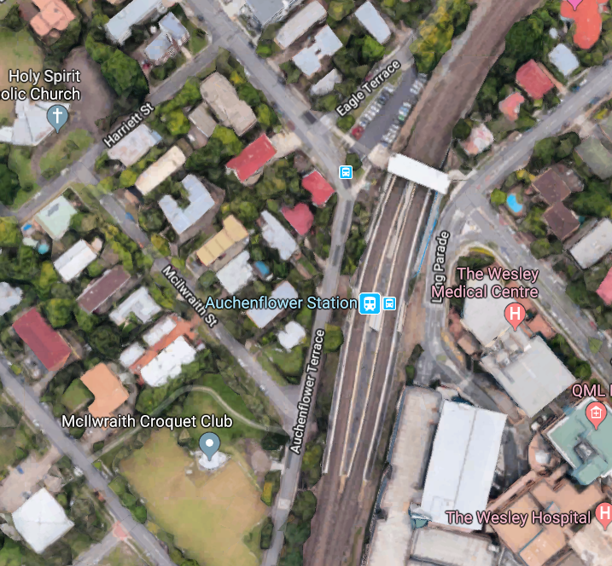
Map data © Google, 2020
Road closure – Auchenflower Terrace

Traffic detour

Tree removal zone

Lane closure, Lang Parade (crane placement)
Ridley Street
Lang Parade

For more information, please contact the project’s community team on free call 1800 722 203 or email stationsupgrade@qr.com.au

We are moving towards paperless notifications about noise and works. You will still see paper notices as we transition to the new system. Sign up at queenslandrail.com.au/EmailNotification or contact us if you prefer to receive paper copies.

