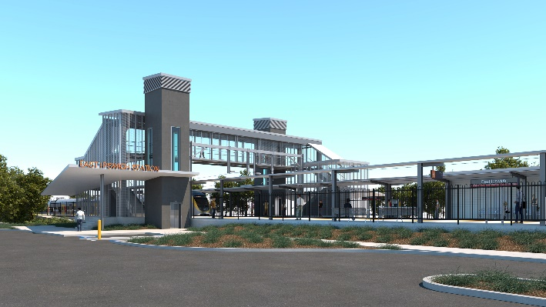
East Ipswich station accessibility upgrade

WORKS NOTICE

Coronation Street station entrance closed for upgrade works

Between Monday 26 October and mid-November 2020,
9am to 4pm (Mon-Sat) RESCHEDULED

Pedestrian detour to the station via Gibbon Street, York Street, Cordelia Street and Bennett Street.
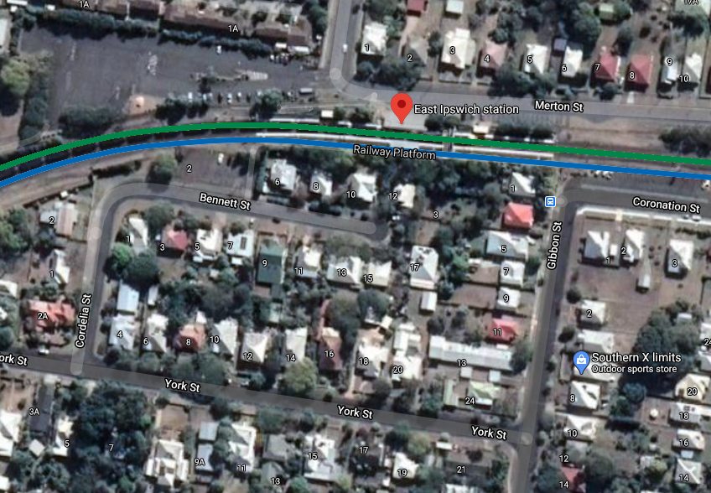

Queensland Rail Limited ABN 71 132 181 090

Station entrance closed, 9am to 4pm (M-Sa)

Pedestrian detour

Map data © Google, 2020

Thank you for your patience while we build you a better station.
For more information, please contact the project’s community team on free call 1800 722 203 or email stationsupgrade@qr.com.au

Sign up for paperless notifications at queenslandrail.com.au/EmailNotification

