16 May to 13 June 2016
Signals Upgrade Project

This is the second of a regular notice you will receive to keep you informed of works in your area associated with our Signals Upgrade Project. This four-week look ahead is intended to provide an outline of planned works and their approximate location so you will know what Queensland Rail is doing and where.
The nature of this work is such that there will be little to see, but there will be construction noise and traffic impacts, particularly around those points where we require access to the rail corridor.
We apologise for any inconvenience and thank you for your understanding while we dig trenches, lay cables, move overhead electrical wires and install new signalling equipment on the line between Roma Street and Corinda.
Indooroopilly and Taringa

Works
Night works over the weekends for drilling signal portal foundations.
From 6pm Saturday 21 May to 2am Monday 23 May
From 2am Saturday 28 May to 3am Monday 30 May
From 11pm Saturday 11 June to 7pm Sunday 12 June.
What to expect
- Heavy vehicle movements, periodic traffic control near train line access gates, some noise, construction crews in area.
- Ongoing traffic control and heavy vehicle movements on streets surrounding worksites.
- Minor traffic delays, reversing alarms, extra heavy vehicles and equipment movements and parking on street.
- Night works - bright lighting, vibration, vehicle movements and noise from construction crews and machinery.

Milton
Works
Night works for overhead line reconfiguration works
Between 10pm and 5am each night:
Over five nights, from Sunday 22 May to Thursday 26 May
Over two nights, from Sunday 12 June to Monday 13 June.
What to expect
Some noise from on track machines and construction crews, lighting, heavy vehicle movements, traffic control in surrounding streets.
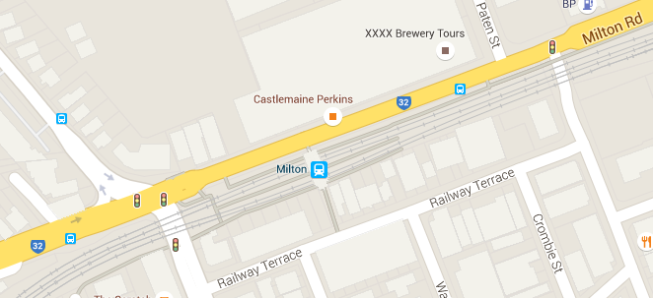

Graceville to Taringa trench digging
Works | What to expect
Day works  Trench digging within the rail corridor for cable installation between Graceville and Taringa stations.  16 May – 12 June | Noise from excavator, heavy vehicle movements, construction crews in area, ongoing traffic control in surrounding streets.
Queensland Rail will make every effort to carry out its works with minimal disruption, and encourages you to contact us with your phone or email details so that we can ensure you are notified of any works that need to take place outside of normal construction hours or involve changed traffic arrangements in your area.
This snapshot is broad and subject to change. If you have questions or concerns about specific dates, times or locations, please contact us. We look forward to working with you.
Progress update
Significant works were completed during the Scheduled Corridor Access System (SCAS) closure on 7/8 May. This included:
- installation of six new signal portals from Long Street East at Graceville, to Albert Bridge at Indooroopilly
- installation of 12 trenched signalling under track crossings for the provision of local and mains signalling cables between Corinda and Albert Bridge, Indooroopilly
- soil investigations in various locations between Roma Street and Corinda to facilitate the design of new signal gantries
- installation of signal portal foundations in the Indooroopilly area
- installation of new temporary foundations at Auchenflower.
Contact:
Call: 1800 399 222 Email: communityengagement@qr.com.au
For more information about this project visit the Queensland Rail website at www.queenslandrail.com.au/inthecommunity/projects

