20 April to 15 May 2016
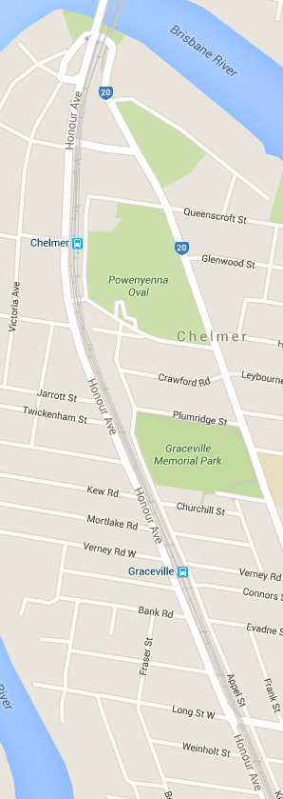
Signals Upgrade Project

This is the first of a regular notice you will receive to keep you informed of works in your area associated with our Signals Upgrade Project. This four week look ahead is intended to provide an outline of planned works and their approximate location so that you will know what Queensland Rail is doing where.

The nature of this work is such that there will be little to see but there will be construction noise and traffic impacts, particularly around those points where we require access to the rail corridor.
We apologise for any inconvenience and thank you for your understanding while we dig trenches, lay cables, move over head electrical wires and install new signalling equipment on the line between Roma Street and Corinda.
This snapshot is broad and subject to change. If you have questions or concerns about specific dates, times or locations, please contact us. We look forward to working with you.
Indooroopilly to Sherwood station

Works | What to expect
23 – 24 April: Day works for drilling signal portal foundations. | Heavy vehicle movements, periodic traffic control near train line access gates, some noise, construction crews in area.
Ongoing traffic control and heavy vehicle movements on Honour Ave, Appel St and Chelmer St East. | Minor traffic delays, reversing alarms, extra heavy vehicles and equipment movements and parking on street.
Under-boring for signal installation at Bridge St underpass. | Heavy vehicle movements, some noise and minor vibration. No planned changes to traffic conditions.
2 May – assembly of signal portal on Honour Ave near Graceville Station prior to installation. | Traffic control on Honour Ave, minor traffic delays, heavy vehicle movements, noise from machinery and reversing alarms.
Milton station
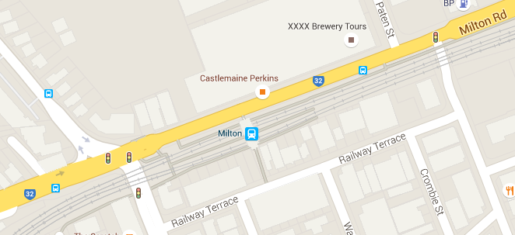

Works | What to expect
29 April – Night works, test excavations prior to scheduled corridor shutdown in May. | Night works, lighting, noise from excavator, heavy vehicle movements, construction crews in the area.

Roma Street to Corinda, Yeerongpilly and Murarrie
During a scheduled corridor shutdown of the line from Roma Street to Corinda, Yeerongpilly and Murarrie, from 2am Saturday 7 May to 3am Monday 9 May, there will be heightened activity in the entire rail corridor between Roma Street and Corinda. A separate notice will be distributed to provide details of this.
Queensland Rail will make every effort to carry out these works with minimal disruption, and encourage you to contact us with your phone or email details so that we can ensure you are notified of any works that need to take place outside of normal construction hours or involve changed traffic arrangements in your area.

Contact:
Call: 1800 399 222
Email: communityengagement@qr.com.au
For more information about this project visit the Queensland Rail website at www.queenslandrail.com.au/inthecommunity/projects

