1 April to 30 April 2017
Signals Upgrade Project
As a valued neighbour, we are committed to keeping you informed about work Queensland Rail is doing in your area. This notice is a four-week look ahead outlining planned work for our Signals Upgrade Project and approximate locations, so you are fully informed.
The nature of this work is such that there will be little to see, but there will be construction noise and traffic impacts, particularly around those points where we require access to the rail corridor.
We apologise for any inconvenience and thank you for your understanding while we dig trenches, lay cables, move overhead electrical wires and install new signalling equipment on the line between Roma Street and Corinda.
Queensland Rail wishes you and your family a safe and Happy Easter.

Toowong to Auchenflower overhead night works
Night works for overhead booster installations 50 metres either side of Camford Street.  From 12.30am to 4.30am on:  - Monday 10 April  - Tuesday 11 April  - Wednesday 12 April  - Thursday 13 April.  Night works for overhead transformer installations near Dixon Street.  From 12.30am to 4.30am on:  - Wednesday 26 April  - Thursday 27 April  - Friday 28 April. | 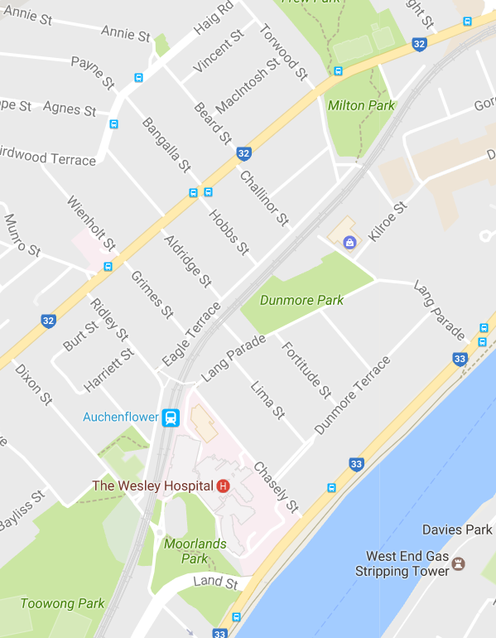
What to expect
Some noise from on-track machines and construction crews, heavy vehicle movements and traffic control in surrounding streets.

Milton to Indooroopilly weekend works
From 6am to 6pm each day on Saturday 1 April and Sunday 2 April.  - Electrical cable route upgrades between Milton and Auchenflower stations.  - Cable route upgrades between Taringa and Indooroopilly stations.  - Shotcrete installation at Chelmer.  From 6am to 6pm each day on Saturday 22 April and Sunday 23 April.  - Day works for trackside installations near Land Street, Toowong.  - Installation of on track signalling equipment from Milton to Toowong.  - Electrical cable route upgrades between Taringa and Indooroopilly stations. | 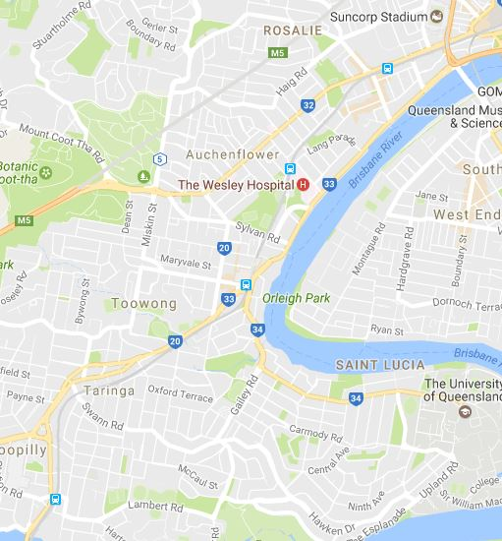
What to expect | 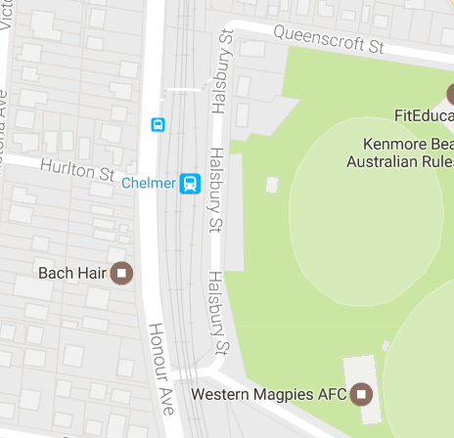
Some noise from on-track machines and construction crews, heavy vehicle movements and traffic control in surrounding streets.
Milton to Graceville day works
Ongoing daily conduit installation between Milton and Graceville involving construction crews accessing the corridor and heavy vehicle movements.
Queensland Rail will make every effort to carry out its works with minimal disruption. We encourage you to contact us with your phone or email details so we can ensure you are notified of any works that need to take place outside of normal construction hours, or involve changed traffic arrangements in your area.
This snapshot is broad and subject to change. If you have questions or concerns about specific dates, times or locations, please contact us. We look forward to working with you.

Contact:
Call: 1800 959 989
Email: communityengagement@qr.com.au
For more information about this project visit the Queensland Rail website at www.queenslandrail.com.au/inthecommunity/projects

