17 July to 14 August 2016
Signals Upgrade Project

This is the fourth of a regular notice you will receive to keep you informed of works in your area associated with our Signals Upgrade Project. This four-week look ahead is intended to provide an outline of planned works and their approximate location so you will know what Queensland Rail is doing and where.
The nature of this work is such that there will be little to see, but there will be construction noise and traffic impacts, particularly around those points where we require access to the rail corridor.
We apologise for any inconvenience and thank you for your understanding while we dig trenches, lay cables, move overhead electrical wires and install new signalling equipment on the line between Roma Street and Corinda.
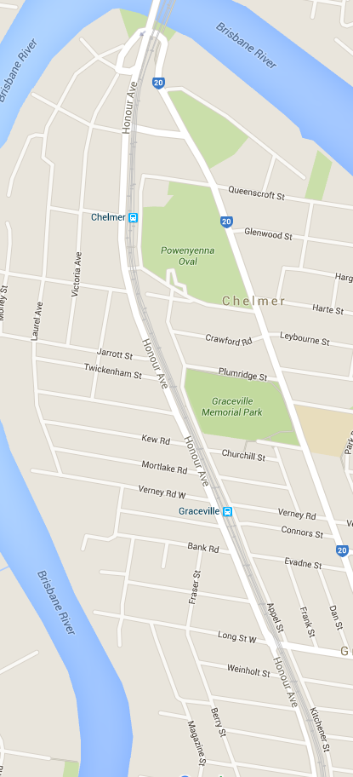
Graceville and Chelmer overhead works

Works
Over five nights, from Sunday 17 July to Friday 22 July.
Night works for overhead line reconfiguration works between the Brisbane River and Graceville stations.
Between 10pm and 5am each night
What to expect
Some noise from on track machines and construction crews, lighting, heavy vehicle movements, traffic control in surrounding streets.
Graceville under track boring
Works
Commencing mid-July 2016
Boring for signal conduits near Graceville station.
What to expect
- Heavy vehicle movements, construction crews in area, some noise, drilling, minor vibration in close proximity to site.
- Minor traffic delays, reversing alarms, extra heavy vehicles and equipment movements and parking on street.

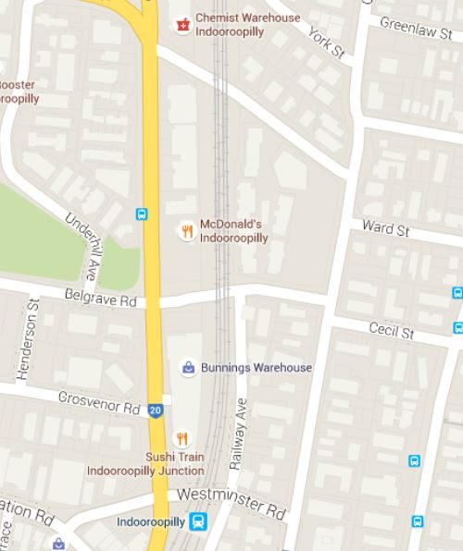
Indooroopilly and Taringa foundation works

Works
23 July to 25 July 2016

Day works over the weekend for the installation of signal portal foundations.
What to expect
- Heavy vehicle movements, periodic traffic control near train line access gates, some noise, construction crews in area, excavations and drilling.
- Ongoing traffic control and heavy vehicle movements on streets surrounding worksites.
- Minor traffic delays, reversing alarms, extra heavy vehicles and equipment movements and parking on street.
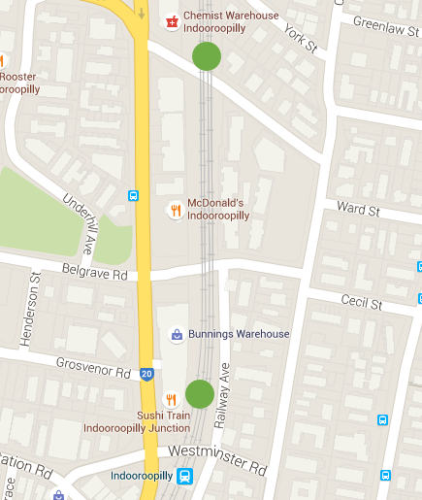

Taringa to Milton cable route
Works | What to expect
Commencing mid-July 2016  Cable route installation day works. | Some noise from on track machines and construction crews, lighting, heavy vehicle movements, traffic control in surrounding streets.

Roma Street to Corinda track closure
During a scheduled corridor shutdown of the line from Roma Street to Corinda, Yeerongpilly and Murarrie from 2am Saturday 30 July to 3am Monday 1 August, there will be heightened activity in the entire rail corridor between Roma Street and Corinda. Work for this project will include:
- Foundation installations at signal portal locations between Taringa and Milton
- Portal structure installations with crane lifts at portal locations between Indooroopilly and Taringa
- Under track crossing works at various locations around the signal portals from Graceville to Indooroopilly to Taringa
- Signal dropper and head installations at the portal locations between Graceville and Indooroopilly.

Queensland Rail will make every effort to carry out its works with minimal disruption, and encourages you to contact us with your phone or email details so that we can ensure you are notified of any works that need to take place outside of normal construction hours or involve changed traffic arrangements in your area.
This snapshot is broad and subject to change. If you have questions or concerns about specific dates, times or locations, please contact us. We look forward to working with you.
Contact:
Call: 1800 399 222 Email: communityengagement@qr.com.au
For more information about this project visit the Queensland Rail website at www.queenslandrail.com.au/inthecommunity/projects

