29 August to 26 September 2016
Signals Upgrade Project

As a valued neighbour, we are committed to keeping you informed about work Queensland Rail is doing in your area. This notice is a four-week look ahead outlining planned work for our Signals Upgrade Project and approximate locations, so you are fully informed.
The nature of this work is such that there will be little to see, but there will be construction noise and traffic impacts, particularly around those points where we require access to the rail corridor.
We apologise for any inconvenience and thank you for your understanding while we dig trenches, lay cables, move overhead electrical wires and install new signalling equipment on the line between Roma Street and Corinda.
Auchenflower earthworks and Power Equipment Room (PER) installation
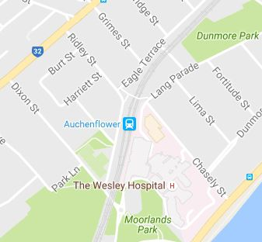

Works to be completed
Over five days, from Monday 29 August to Saturday 3 September 2016.
Earthworks, foundation installation and PER installation at Auchenflower during the day.
What to expect
Some noise from excavation and construction crews, heavy vehicle movements, traffic control in surrounding streets.

Graceville under track boring
Works to be completed
Commencing first week of September 2016 for six weeks.
Boring for signal conduits at Graceville station.
What to expect
Heavy vehicle movements, construction crews in the area, some noise, drilling and minor vibration in close proximity to the site.
Minor traffic delays, reversing alarms, extra heavy vehicles and equipment movements and parking on street.

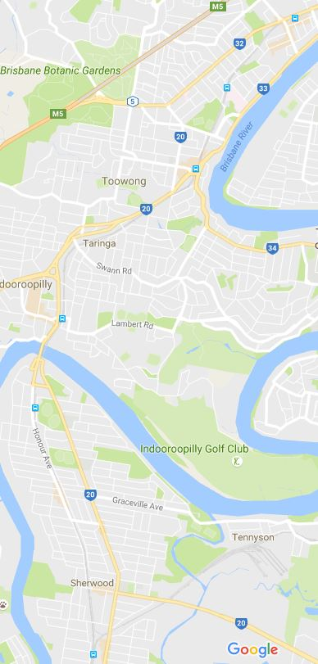
Progress update
Signal portal foundations
Thirty-one signal foundations have been drilled and constructed at multiple locations between Corinda and Milton.
Signal foundations will support the new signal portals, which are being installed as part of the project.
Underboring for signal conduits
Underboring of track and roads has occurred at multiple points between Corinda and Auchenflower to run signal conduits.
Underboring allows for important signal conduits to be installed without the need for heavy construction impacts.
Assembly and installation of signal portals
Signal portals have been installed over the train tracks at twelve locations between Corinda and Taringa.
The signal portals are large structures similar to gantries, which will suspend signals over the tracks. Cranes are required to lift the portals into place.
Overhead line reconfiguration
In some locations, overhead lines need to be reconfigured to match the signal and track modifications.
The overhead line reconfiguration at Milton is necessary to support the installation of a new track cross over.

Queensland Rail will make every effort to carry out works with minimal disruption. We encourage you to contact us with your phone or email details so that we can ensure you are notified of any works that need to take place outside of normal construction hours or involve changed traffic arrangements in your area.
This activity snapshot is broad and subject to change. If you have questions or concerns about specific dates, times or locations, please contact us. We look forward to working with you.
Contact:
Call: 1800 399 222 Email: communityengagement@qr.com.au
For more information about this project visit the Queensland Rail website at www.queenslandrail.com.au/inthecommunity/projects

