*Timber bridge, Kavanagh Road East, Thagoona.*

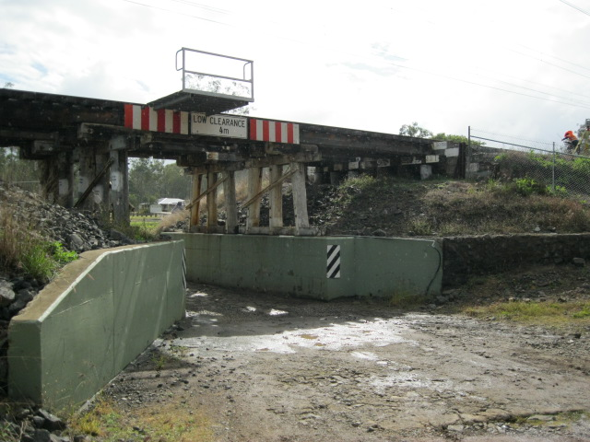

**Timber rail bridge replacement program – construction commences**

Queensland Rail is replacing a series of rail bridges on the Ipswich to Rosewood line, in South East Queensland.

Under this program, ageing timber bridges will be replaced with steel and concrete structures to improve reliability, operational safety and efficiency of services on the rail corridor.

Five timber rail bridges in the City of Ipswich – all between 100 and 150 years old – will be upgraded or replaced as part of this program.

The five bridges are at:

* Kavanagh Road East, Thagoona – replacement
* Karrabin – replacement
* Guilfoyles Gully, Walloon – replacement
* Rosewood – replacement
* Sadliers Crossing – upgrade of timber approaches.

The treatment for each bridge will vary depending on the bridge condition, surrounding site and scale of the replacement or upgrade.

**Construction update**

Queensland Rail has appointed contractor JF Hull Holdings to undertake four of the bridge replacements: Karrabin, Guilfoyles Gully, Kavanagh Road East and Rosewood.

Construction is expected to begin at Kavanagh Road East and at other bridge locations late June 2015. Where possible, the overall program schedule has been planned to deliver works simultaneously at multiple sites for greater efficiency, to minimise line closures, disruption to passenger services and impacts on the community.

The site office to service the four bridges will be established on Queensland Rail land adjacent to the Walloon rail station. Queensland Rail is working with the contractor to minimise impacts of site office activities.

Access to the site office will be via Railway Street, Walloon and traffic management measures will be in place for the safety of motorists, pedestrians and rail customers. Parking for project workers is provided inside the fenced site office area.

Replacement of the four bridges is scheduled to be completed mid-2016, weather and construction conditions permitting. Works to upgrade the timber approaches on the fifth bridge at Sadliers Crossing will be undertaken as a separate contract at a later date.

*Timber bridge, Rosewood.*

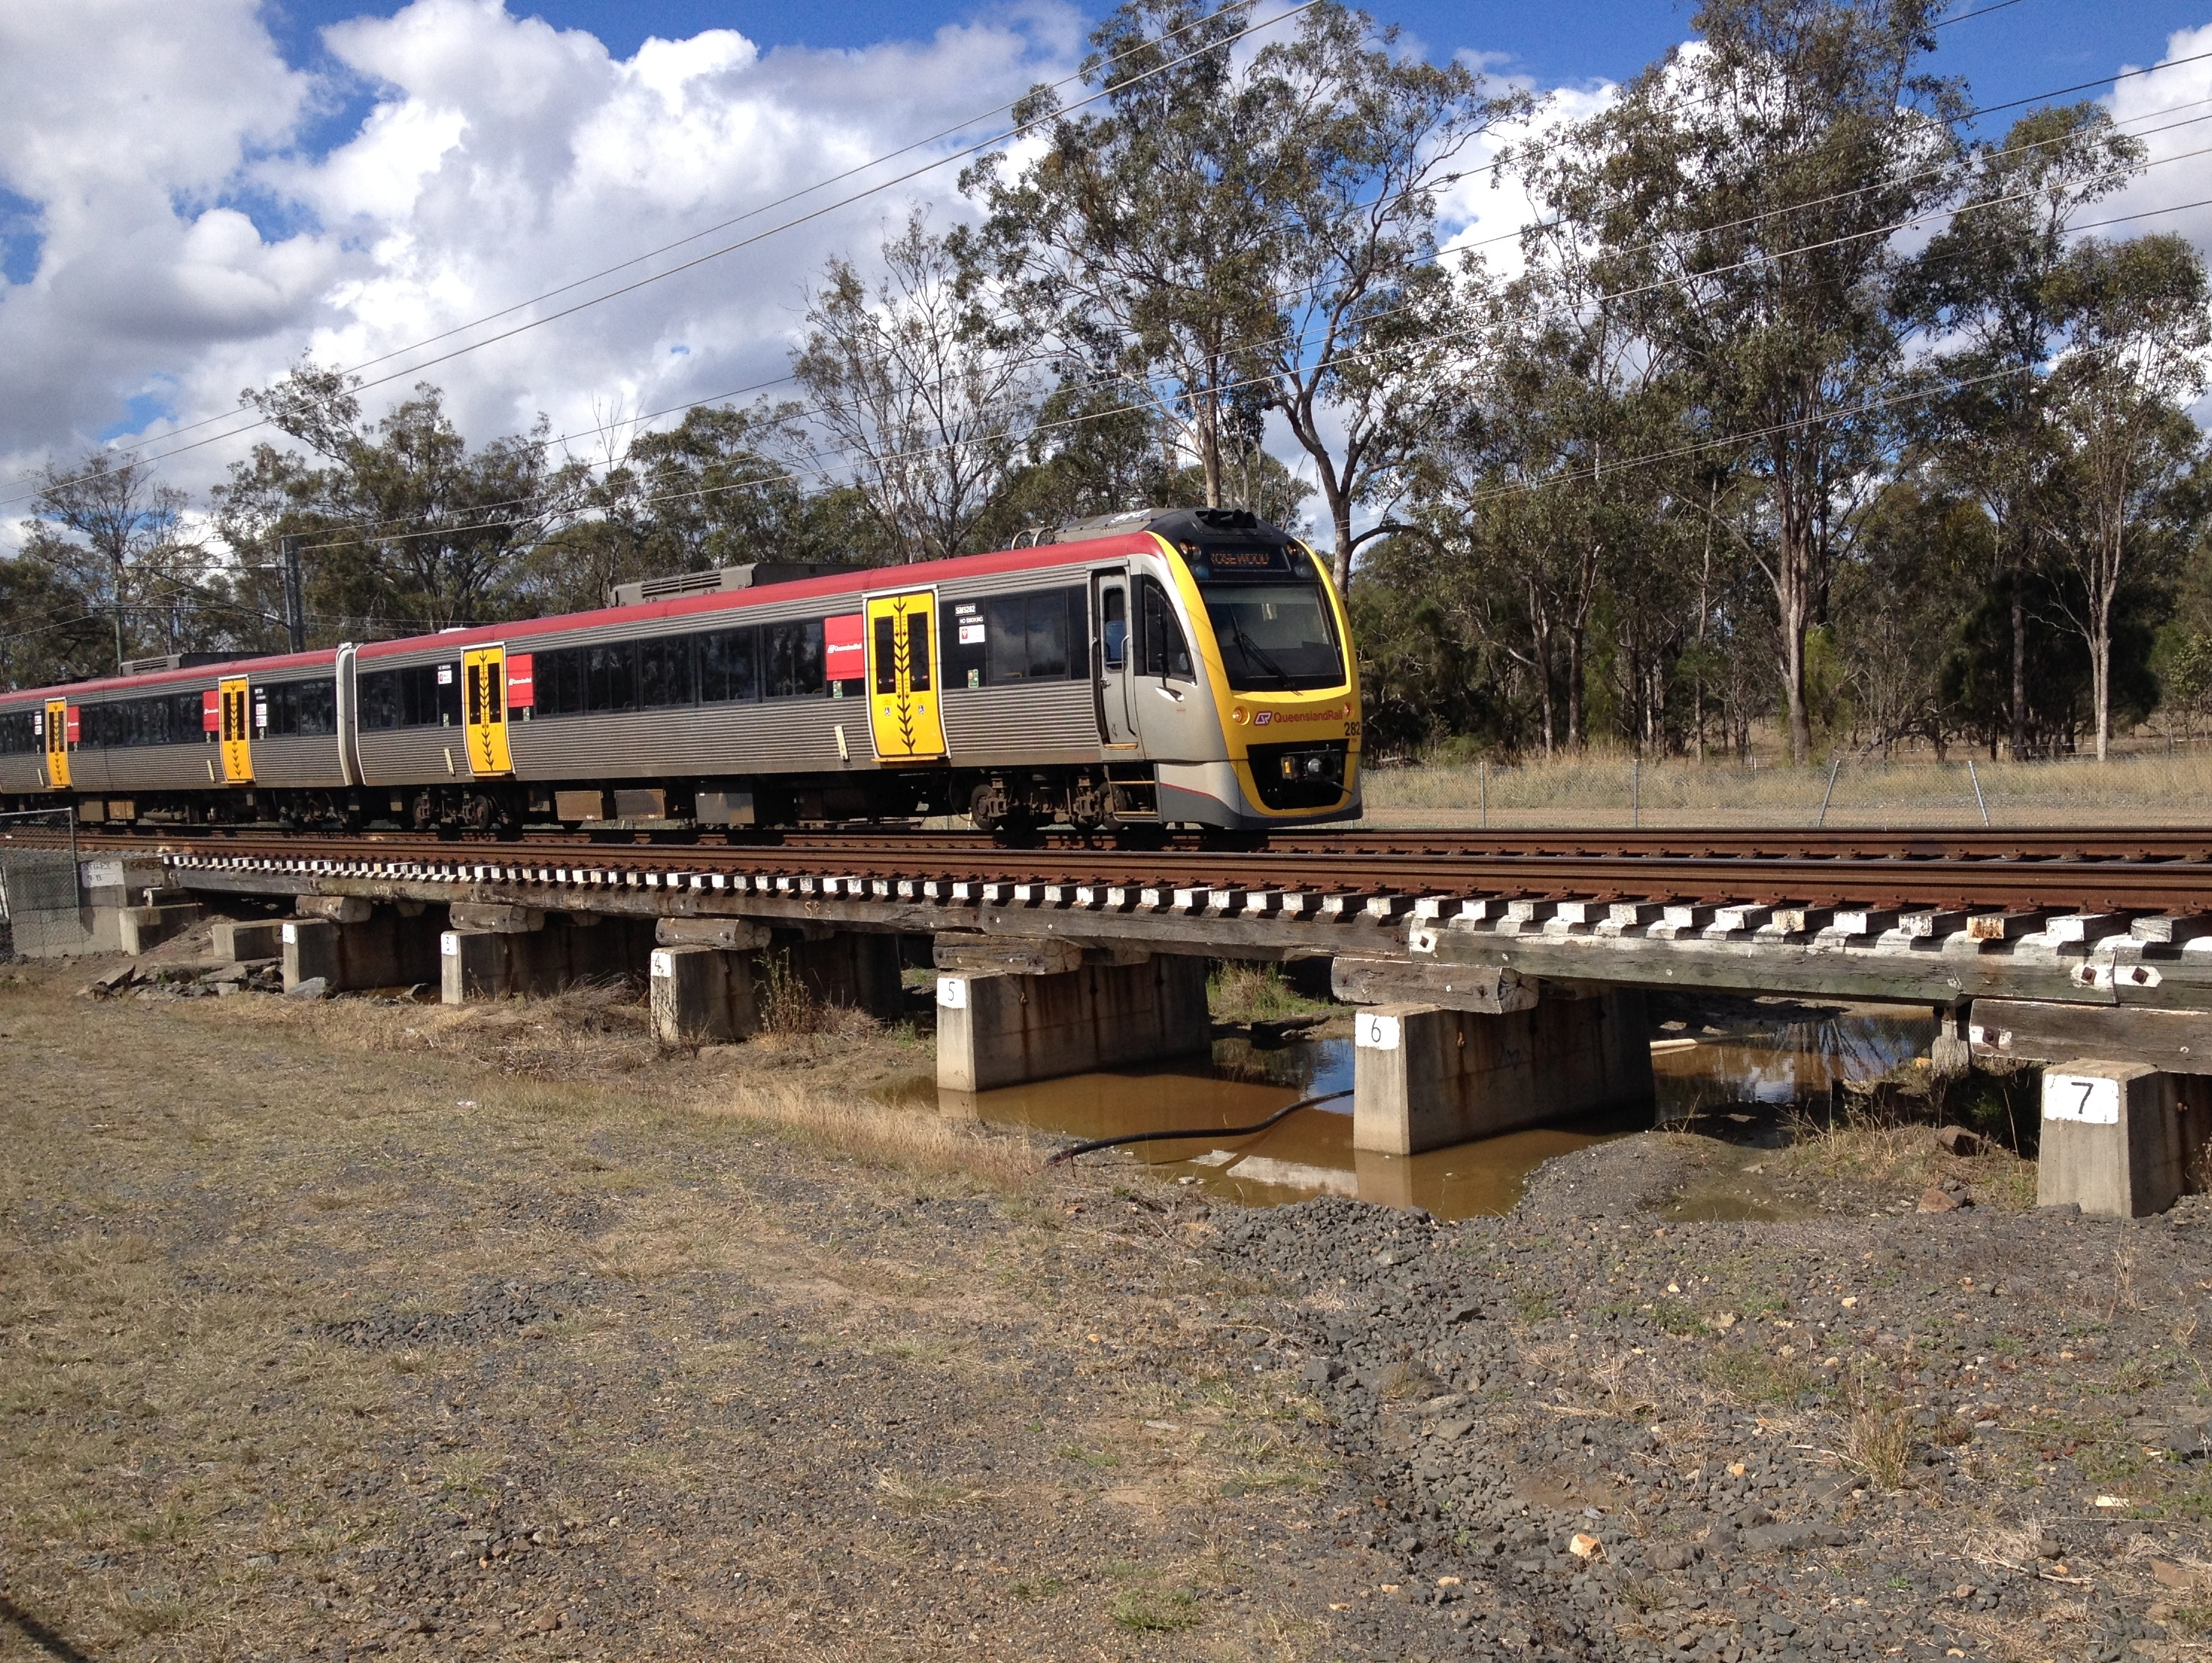

**What is involved?**

Queensland Rail investigated a range of possible bridge replacement options for each location. Investigations also considered hydrology modelling, bridge height clearances and constructability issues.

Construction has been scheduled to coordinate with Ipswich City Council’s flood mitigation works.

All of the bridges will be constructed on their existing alignment. Final bridge installations will be scheduled to occur over a 48-hour period, with a temporary closure of the rail line and around the clock construction works. The old timber bridges will be removed at this time.

**Construction impacts**

Queensland Rail is engaging with potentially affected residents and nearby stakeholders to understand the project impacts and minimise disruption to the community during construction.

The local community may notice increased vehicle movements around the work zones and site office, including delivery of plant and equipment.

Construction impacts for nearby residents may include access, night works, vehicle movements and noise, such as reversing beepers, piling works and materials delivery.

Residents will be given advance notification of periods of heightened activity, temporary access routes and property restrictions, excessive noise or night works, in accordance with Queensland Rail’s community engagement guidelines.

Queensland Rail apologises for any inconvenience and thanks stakeholders and the local community for their cooperation during these important works.

**Safety is our priority**

Safety is the number one priority for Queensland Rail. In order to provide a safe work environment for workers and the community, public access to areas near the construction sites will be restricted during works.

**Keeping you informed**

Queensland Rail is committed to keeping stakeholders and the community informed about the timber bridge replacement program on the Western Corridor – Ipswich to Rosewood line.

For more information about this project, telephone 1800 645 836 seven days or 13 16 17 between 7.15am and 5pm Monday to Friday, or email communityengagement@qr.com.au.