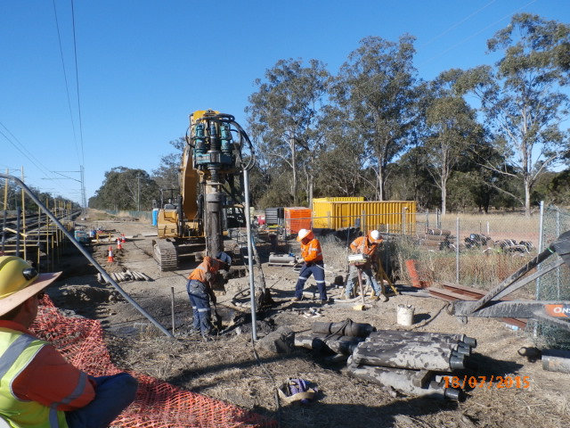

*Piling works, Rosewood.*

**SEQ timber bridge replacement program – construction update**

Construction works are progressing on Queensland Rail’s program to replace a series of rail bridges on the Ipswich to Rosewood line, in South East Queensland. Under this program, ageing timber bridges will be replaced with steel and concrete structures to improve reliability, operational safety and efficiency of services on the rail corridor.

Five timber rail bridges in the City of Ipswich – all between 100 and 150 years old – are being upgraded as part of this program. The five bridges are at:

* Kavanagh Road East, Thagoona
* Karrabin
* Guilfoyles Gully, Walloon
* Rosewood
* Sadliers Crossing – timber approaches.

**Construction update**

A staged construction program commenced in June this year.

Where possible, the overall schedule has been planned to deliver works simultaneously at multiple sites for greater efficiency, to minimise line closures, disruption to passenger services and impacts on the community.

JF Hull Holdings is undertaking the works at Thagoona, Karrabin, Guilfoyles Gully and Rosewood. Doval Constructions (Qld) is undertaking works at Sadliers Crossing.

For completion of works, see the project timeline over the page.

Queensland Rail has been working closely with Ipswich City Council to ensure that, where necessary, bridge replacement activities coordinate with Council’s flood mitigation works program. In particular, additional consultation with Council will produce an integrated schedule that will enable Council to commence flood mitigation control works after the bridge and associated works at Kavanagh Road East are completed in January 2016.

**Site access**

To ensure safe access for construction personnel to and from site, temporary changes to traffic conditions are required at some bridge sites.

Queensland Rail is working with its contractors to minimise any impacts to the community as well as with Council and emergency services to ensure impacts are minimised and the health and safety of all stakeholders is maintained.

*Weather and construction conditions permitting.*

**Project timeline**

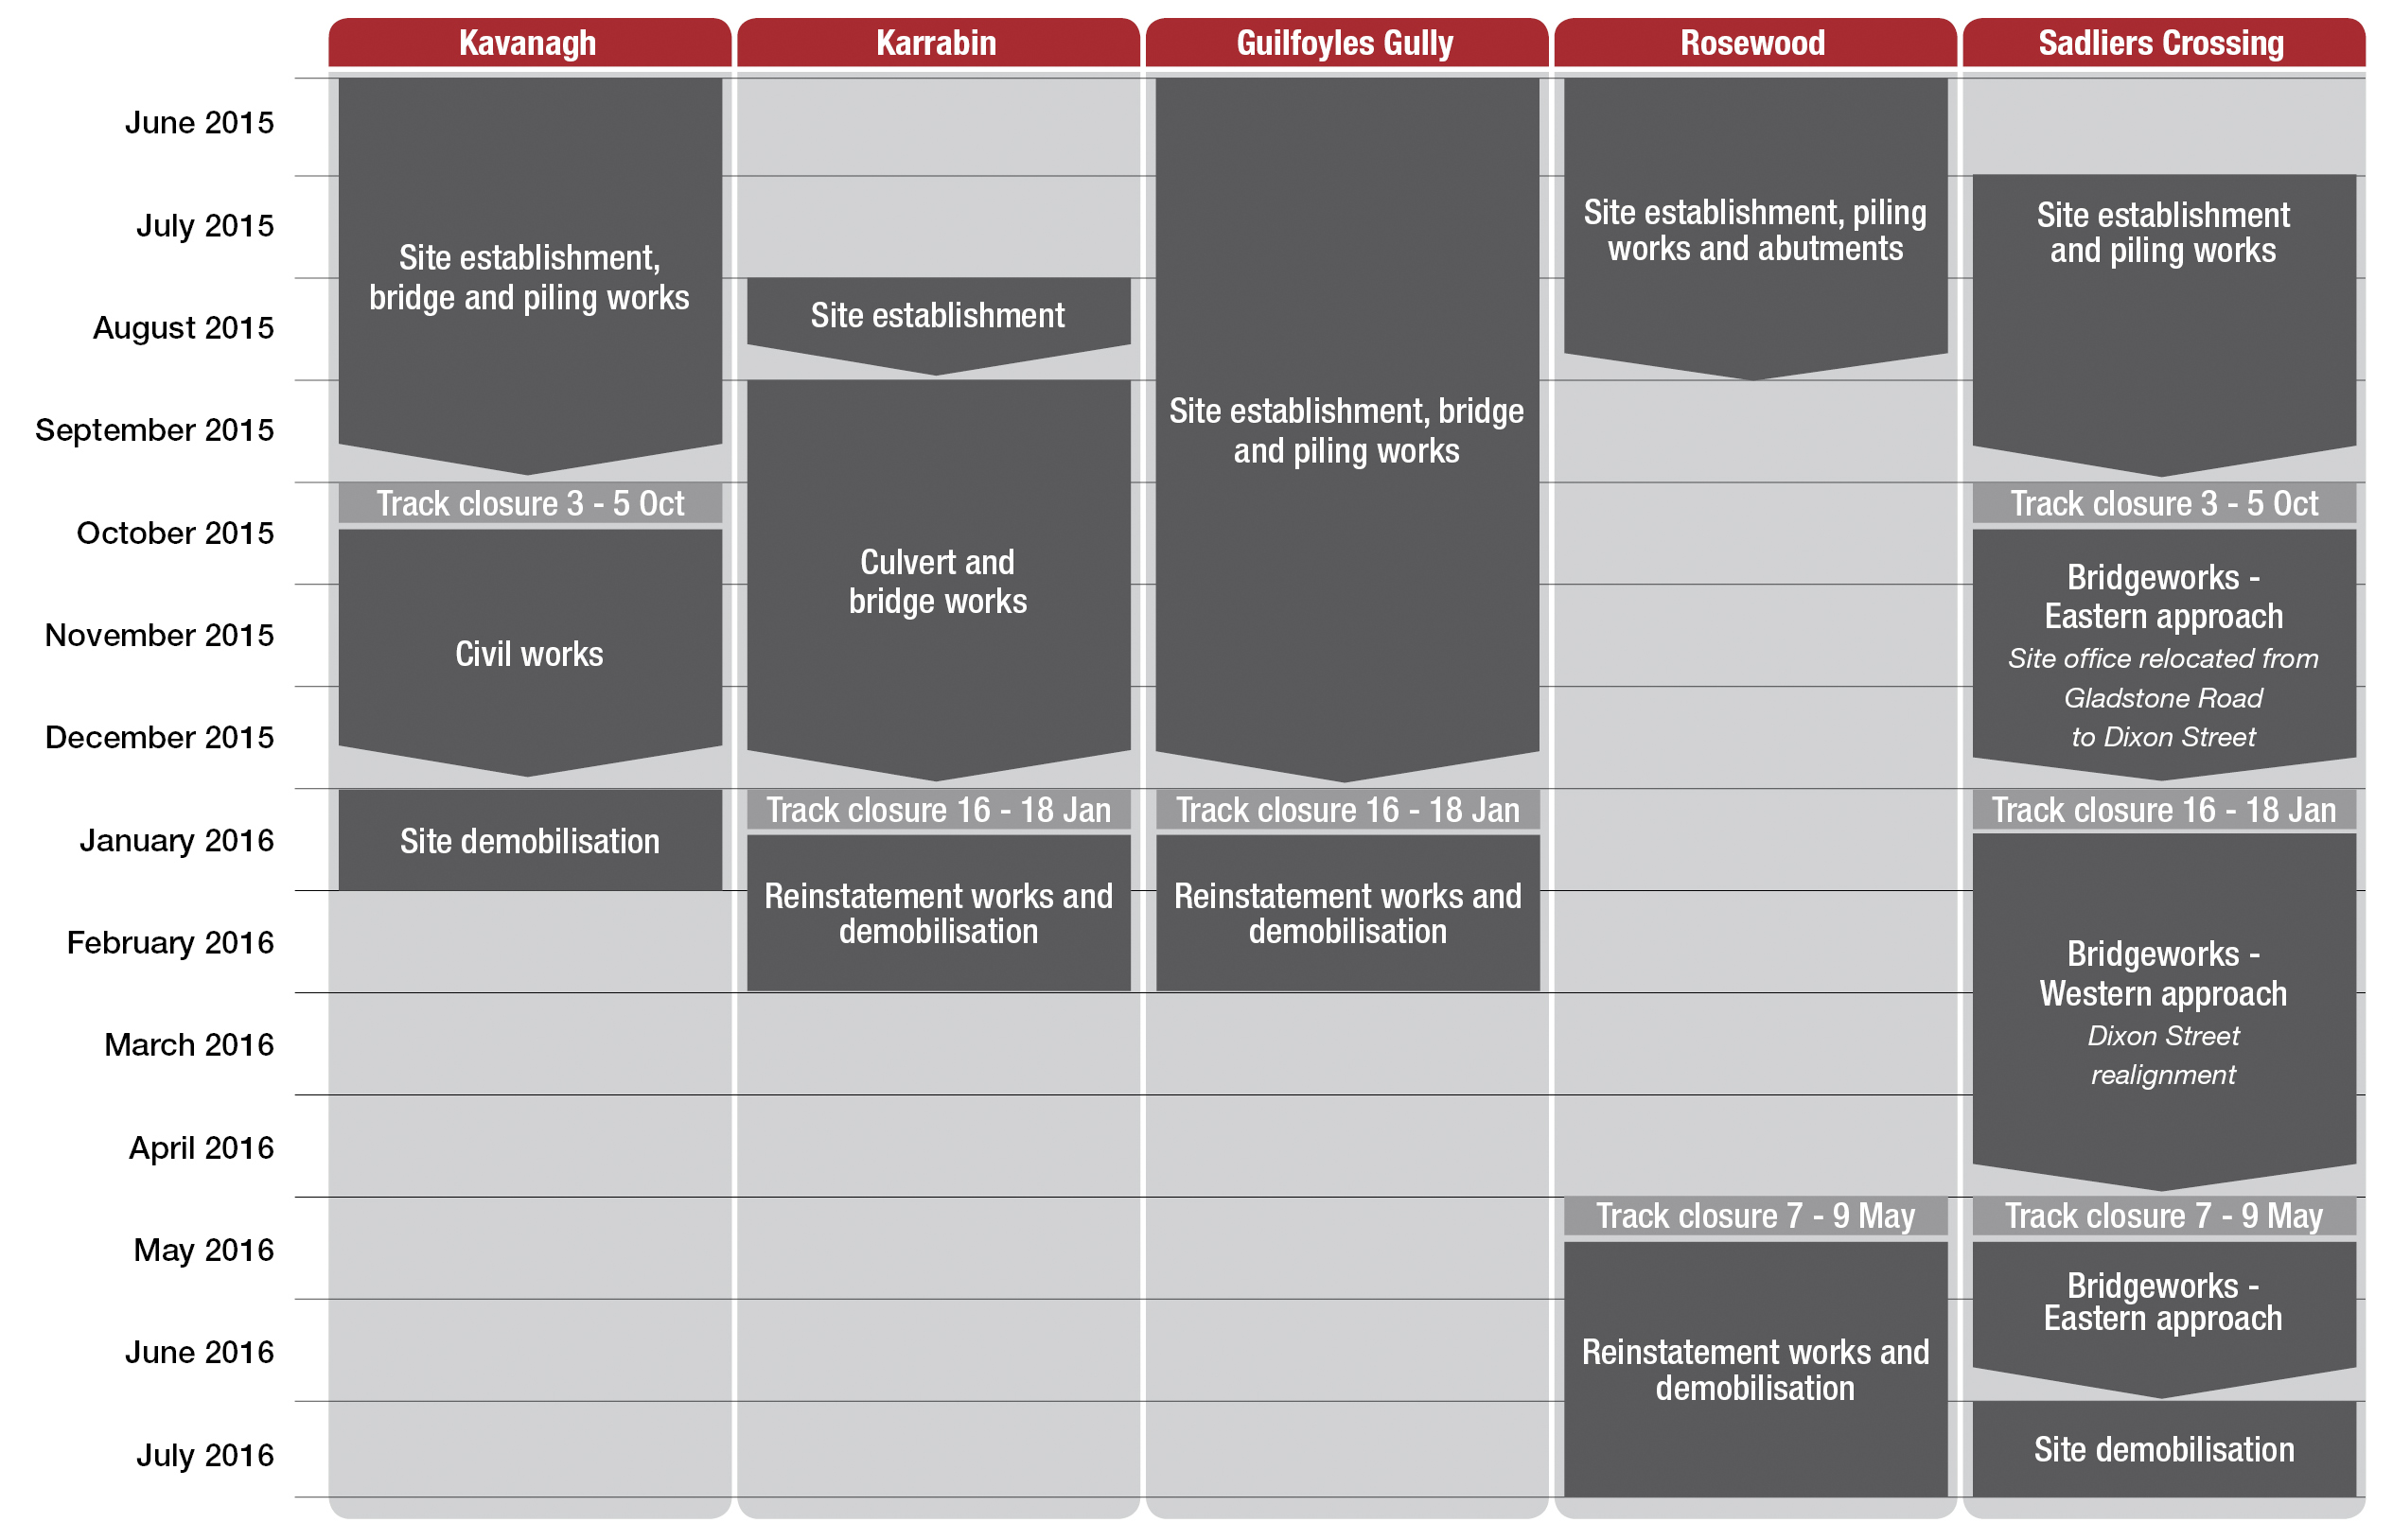

**What to expect**

Scheduled work hours are 7am – 5pm Monday to Saturday. Some night and weekend works may be required. The types of activities the local community may notice around the work zones include increased vehicle movements, materials delivery, use of heavy machinery and changed traffic conditions. As a result of works, the community may experience traffic delays, temporary access changes and increased noise levels.

Nearby residents and affected stakeholders will be given advance notification of periods of heightened activity, temporary access routes, excessive noise or night works, in accordance with Queensland Rail’s community engagement guidelines.

Queensland Rail appreciates your patience and cooperation during these important works. We will continue to engage with potentially affected residents and nearby stakeholders to understand the project impacts and minimise disruption to the community during construction.

**Keeping you informed**

For more information about this project, telephone 1800 645 836 (free call) or email communityengagement@qr.com.au.

Contact Queensland Rail’s customer feedback team on 13 16 17 between 8am and 5pm Monday to Friday or email customerfeedback@qr.com.au.