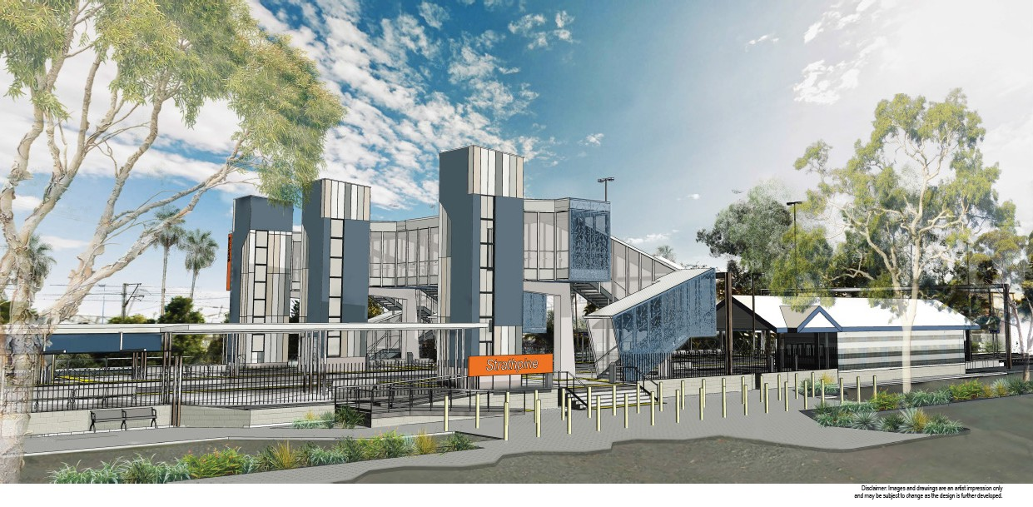Strathpine station accessibility upgrade

As part of the Station Accessibility Upgrade Program, Queensland Rail is making improvements to Strathpine station to allow customers safer and easier travel.

These improvements include:
- a new pedestrian footbridge with lift access
- raised section of platform at assisted boarding points
- extended platform shelters
- upgraded station entrances
- a refurbished unisex accessible toilet
- upgraded CCTV and station lighting
- new wayfinding and platform signage.

The project is currently in the design phase and we are seeking your input. Preliminary construction works are scheduled to begin in November 2017, weather permitting.

Feedback
Queensland Rail Limited ABN 71 132 181 090 QR2017_A4_0517
Queensland Rail is interested to hear your feedback about the Strathpine station accessibility upgrade. Feedback forms are available at the station or online (queenslandrail.com.au) and can be handed in to station staff or emailed to the Stations Upgrade Project team.

Contact us
For more information, contact the Station Upgrade Project team on 1800 722 203 or email stationsupgrade@qr.com.au

