**Toowoomba Range Clearance Upgrade**

**Works notification ­– February 2018**

Queensland Rail is undertaking works for the Toowoomba Range Clearance Upgrade project in late February. This project involves increasing the height of 11 heritage listed tunnels between Toowoomba and Brisbane to ensure more exporters can use rail services. The project will help support the growth and prosperity of Queensland’s agricultural sector.

The project will take approximately nine months to complete. For the safety of our workers and to minimise the impacts to freight and passenger services, the majority of works will be carried out during scheduled track closures.

In February, the works will occur at a number of tunnels located along the West Moreton rail line between Holmes and Blue Mountain Heights. Please see the map overleaf for more information.

The works are planned to commence on Friday 23 February at 11pm and will be completed by Tuesday 27 February at 11pm. Works will occur on a 24 hour basis during this time.

**Overview of work**

|  |  |  |
| --- | --- | --- |
| **Location** | **Dates and hours of work** | **Type of work** |
| Multiple locations between Holmes and Blue Mountain Heights (please see map overleaf) | **From 11pm Friday 23 until 11pm Tuesday 27 February**  (continuous works) | Site preparation, including mobilisation of plant and machinery, drilling and installing rock bolts inside tunnels.  This will involve:   * drilling within tunnels * installation of rock anchors at the base of tunnel walls * a generator * lighting towers at tunnel entrances * the delivery of materials and machinery * light vehicle movements, including reversing beepers and flashing safety lights. |

Queensland Rail is aware noise and lighting from such operations can cause temporary inconvenience to our valued neighbours. Every effort will be made to carry out these works with minimal disruption.

For more information, please call **13 16 17** (during business hours) or email **communityengagement@qr.com.au**

**Works location**

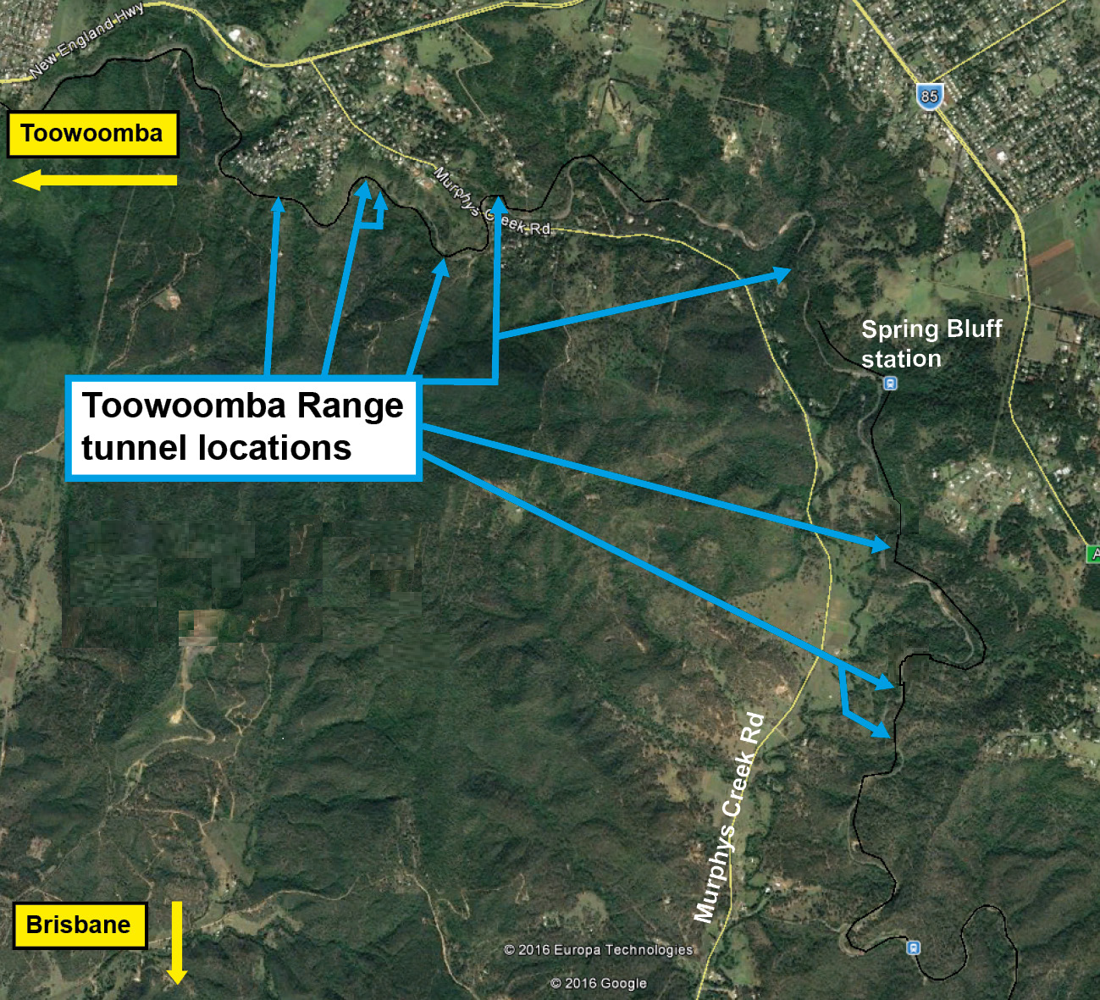

We are moving towards paperless notifications about noise and works. You will still see paper notices as we transition to the new system. Sign up at: **queenslandrail.com.au/EmailNotification** or contact us if you prefer to receive paper copies.