**Toowoomba Range Clearance Upgrade**

**Works notification – June 2018**

Queensland Rail is continuing works for the Toowoomba Range Clearance Upgrade project. This project involves increasing the height of 11 heritage-listed tunnels between Toowoomba and Brisbane to ensure more exporters can use rail services. The project will help support the growth and prosperity of Queensland’s agricultural sector.

To minimise the impacts to freight and passenger services and for the safety of our workers, the majority of works will be carried out during scheduled track closures.

In mid-June, works will occur on the Victoria Tunnel, near Laidley and Six Chain Tunnel, near Grandchester. Please see the map overleaf for more information.

Works will commence at these locations on Saturday 16 June and be completed by Tuesday 19 June. The works will occur between 6am and 6pm daily.

**Overview of work**

|  |  |  |
| --- | --- | --- |
| **Location** | **Dates and hours of work** | **Type of work** |
| Victoria Tunnel | **From 6am Saturday 16 June until 6pm Tuesday 19 June**  (Day shift only) | Site preparation, including mobilisation of plant and machinery, excavation of tunnel, installation of drainage and culverts, drilling and installing rock bolts inside tunnels.  This will involve:   * installation of rock anchors at the base of tunnel walls * a generator * lighting towers at tunnel entrances * the delivery of materials and machinery * light vehicle movements, including reversing beepers and flashing safety lights. |
| Six Chain Tunnel | **From 6am Saturday 16 June until 6pm Sunday 17 June**  (Day shift only) | Site preparation, including mobilisation of plant and machinery, excavation of tunnel, installation of drainage and culverts, reinstatement of tunnel.  This will involve:   * excavation of materials * a generator * lighting towers at tunnel entrances * the delivery of materials and machinery * light vehicle movements, including reversing beepers and flashing safety lights. |

**Vehicles and machines will access the Victoria Tunnel via Ryan Road, Laidley and Six Chain Tunnel via Stokes Road, Grandchester.**

Queensland Rail apologises for any inconvenience to our valued neighbours. Every effort will be made to carry out these works with minimal disruption.

For more information, please call **13 16 17** (during business hours) or email **communityengagement@qr.com.au**

**Work locations**

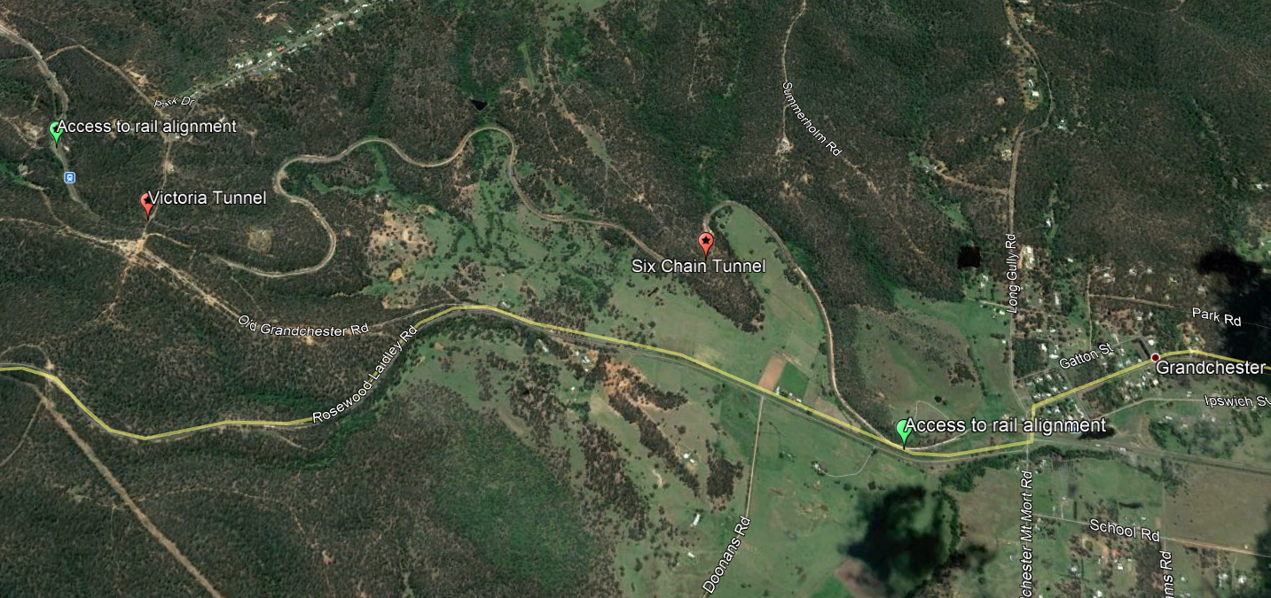

*Map data © 2017 Google*

We are moving towards paperless notifications about noise and works. You will still see paper notices as we transition to the new system. Sign up at: **queenslandrail.com.au/EmailNotification** or contact us if you prefer to receive paper copies.