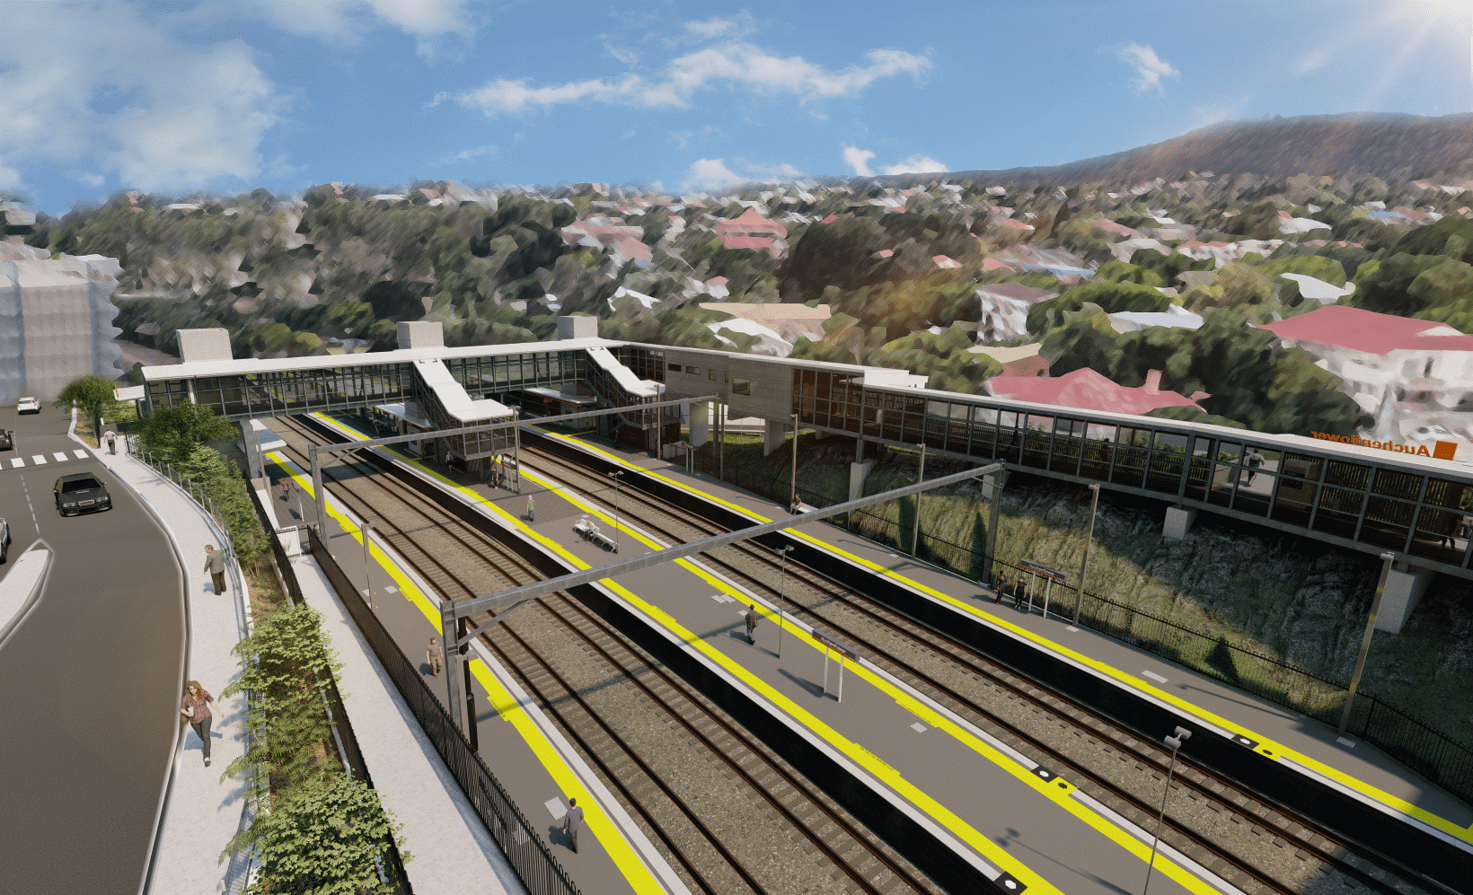

**Auchenflower station accessibility upgrade**

**WORKS NOTICE**

**Night and weekend works UPDATED**

**January 2022**

As part of the Auchenflower station accessibility upgrade, Queensland Rail will undertake night works (**6pm to 6am** the next day) from **Monday 10 to Thursday 13 January and Monday 17 to Friday 21 January**.

These works can only be undertaken after hours when rail traffic is reduced and there are fewer people around the station precinct.

Following preparatory activities, around-the-clock weekend works will be undertaken **from 8pm Friday 14 until 5am Monday 17 January**. During these weekend works, the station will remain open. Customers are advised to check information display screens and project signage as platforms may have changed.

**Lane closures with traffic management may be required at times on Lang Parade and Auchenflower Terrace. Daytime road closures on Auchenflower Terrace will be in place between 6.30am and 5pm each day from Tuesday 4 to Friday 14 January. Lang Parade will also be closed (between Chaseley Street and The Wesley Hospital public carpark) from 8pm Friday 14 to 5am Monday 17 January with access to the hospital carpark via Patrick Lane.** Motorists are advised to follow the instructions of the traffic controllers and drive to the changed conditions.

Residents near the station may experience noise associated with construction activity and the operation of cranes, heavy vehicles and trucks round the work zone. Every effort will be made to minimise disruption and we thank you for your patience during these important works.

# Overview of works (weather and construction conditions permitting)

|  |  |  |
| --- | --- | --- |
| **Location** | **Dates and hours of work** | **Type of work** |
| Auchenflower station and rail corridor  Auchenflower Terrace and Lang Parade | *Night works:*  **6pm to 6am** the next day on:   * **Monday 10 January** * **Tuesday 11 January** * **Wednesday 12 January** * **Thursday 13 January** * **Monday 17 January** * **Tuesday 18 January** * **Wednesday 19 January** * **Thursday 20 January** * **Friday 21 January**   (over nine separate nights)  *Weekend works (around-the-clock):*  **8pm Friday 14 to 5am Monday 17 January** | Station upgrade activities involving:   * platform raising and paving * installation/fit out of walkway, lift shaft and staircase infrastructure * operation of cranes and heavy equipment * the movement of vehicles and machinery with flashing lights and reversing beepers * use of hand-held tools and powered equipment * portable lighting towers in use at night * traffic management and lane closures * daytime road closure – Auchenflower Terrace (4 to 14 January) * full road closure – Lang Parade (14 to 17 January). |

The Auchenflower station accessibility upgrade is part of the State Government’s ongoing investment of more than $500 million to upgrade stations across the South East Queensland network, making them accessible for all customers. For more information, please contact the project’s community team on free call **1800 722 203** or email [**stationsupgrade@qr.com.au**](mailto:stationsupgrade@qr.com.au)

Sign up for electronic notifications at **queenslandrail.com.au/EmailNotification**