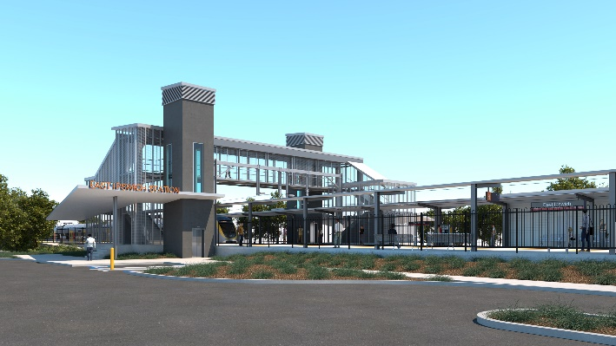

**East Ipswich station accessibility upgrade**

**PROJECT UPDATE – JULY 2020**

**The East Ipswich station accessibility upgrade is part of the State Government’s $357 million investment to upgrade stations across the South East Queensland network, making them accessible for all customers.**

**Project progress**

To date the following works have been undertaken for the East Ipswich station accessibility upgrade:

* concept design
* contractor tender review and assessment
* early works in preparation for main construction
* installation and adjustments to overhead line infrastructure
* ongoing community and stakeholder engagement.

**Upcoming works**

In the coming weeks, customers and the community can expect to see the following activities:

* commencement of detailed design
* contractor mobilisation, site establishment and fencing of work zones
* tree removal (in the rail corridor, Merton Street) to enable construction works
* commencement of main construction (August).

The station upgrade has been designed with consideration given to local trees and preserving the 'look and feel' of the station surrounds.

# Thank you for your patience and cooperation as we build you a better East Ipswich station.

# 

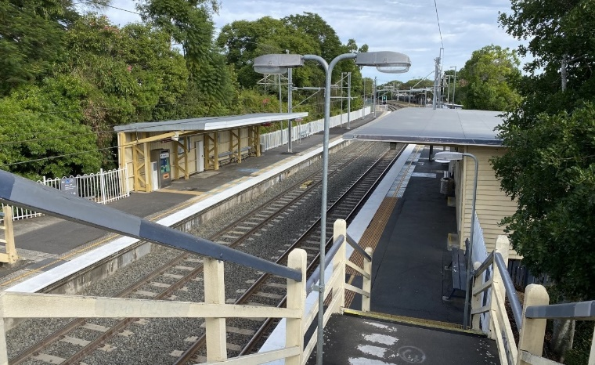

# Construction impacts

# During works, construction activities may involve:

* changed parking and traffic conditions for safety
* noise associated with heavy machinery
* temporary changes to access paths throughout the station precinct and surrounding areas
* increased vehicle movements near works
* mobile lighting towers for night works.

# Normal working hours will be 6.30am to 6.30pm, Monday to Saturday. The local community will be given advance notification of construction activities likely to cause impacts, including after hours work (nights, Sundays and public holidays, if required).

# Drop-in information sessions in July

# This month, visit the project team at the station for community drop-in information sessions:

# Saturday 11 July, 8-11am (includes walking tour)

# Tuesday 14 July, 5-7pm

# Thursday 16 July, 5-7pm

# Contact us

# For more information, to provide feedback or to be added to the project’s opt-in distribution list for email updates:

# Phone: 1800 722 203 (free call)

# Email: stationsupgrade@qr.com.au

# Website: queenslandrail.com.au

# Novel Coronavirus (COVID-19)

# Queensland Rail is committed to keeping essential rail services operating for Queenslanders during this challenging time and to do this, network maintenance and critical works must continue. To support workforce safety, Queensland Rail has implemented a number of additional control measures related to COVID-19 management. We will continue to take the necessary precautions to ensure the ongoing health and wellbeing of our team and the communities in which we operate.