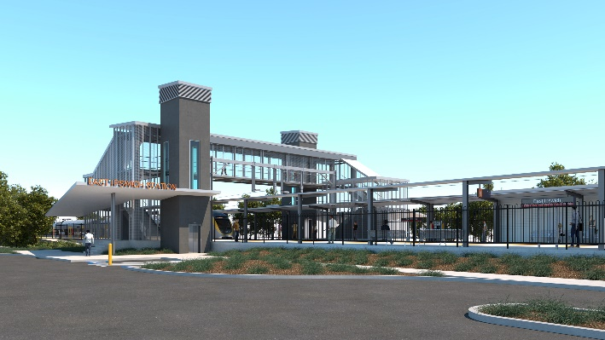
East Ipswich station accessibility upgrade

WORKS NOTICE

Coronation Street station entrance closed for upgrade works

Until late February 2021, 9am to 4pm (Mon-Sat)

Pedestrian detour to the station via Gibbon Street, York Street, Cordelia Street and Bennett Street.
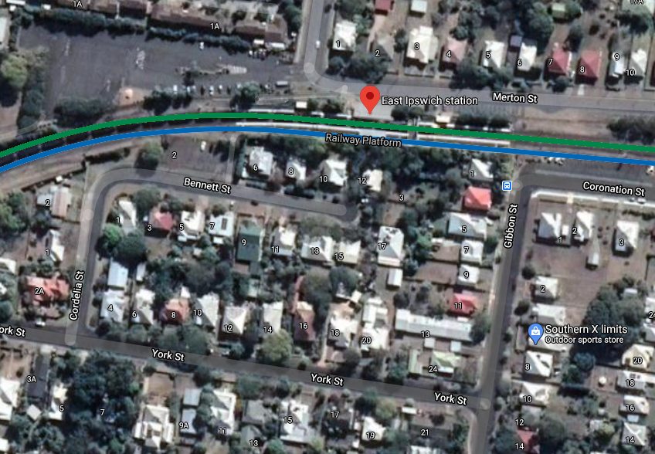

Queensland Rail Limited ABN 71 132 181 090

Station entrance closed,
9am to 4pm (M-Sa)

Pedestrian detour

Map data © Google, 2020

Thank you for your patience while we build you a better station.
For more information, please contact the project’s community team on free call 1800 722 203 or email stationsupgrade@qr.com.au

Sign up for paperless notifications at queenslandrail.com.au/EmailNotification

