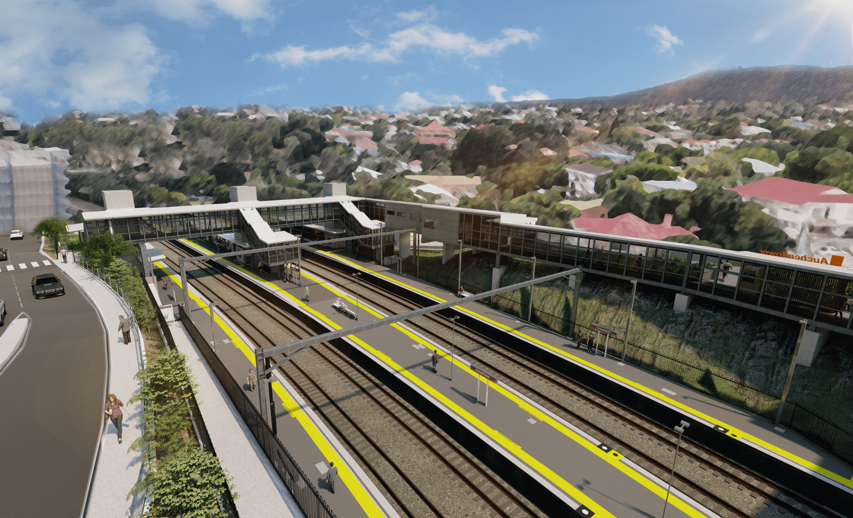
Auchenflower station accessibility upgrade

WORKS NOTICE

Night activities – crane delivery and removal
Sunday 12 to Wednesday 15 December 2021

As part of the Auchenflower station accessibility upgrade, a large crane will be delivered to the Auchenflower Terrace work zone at night on Sunday 12 December, ready to install a section of the new station footbridge.
Footbridge components (steelwork) will be delivered by truck overnight on Monday 13 December for installation during weekday shifts. The crane will be removed from site at night on Tuesday 14 and, if required, Wednesday 15 December (weather and construction conditions permitting).
In the event of wet weather, these works may be rescheduled (without further notification) between Thursday 16 and Monday 20 December.
For safety, crane delivery and removal can only be undertaken after hours when there is reduced rail traffic and fewer people around the station precinct.
Residents near the station may experience noise associated with the delivery, movement and removal of the crane and other project vehicles within the work zone. Every effort will be made to minimise disruption and we thank you for your understanding during these important works.

Overview of out of hours works
Location | Dates and hours of work | Type of work
Auchenflower station  Auchenflower Terrace work zone | 6pm to 6am the next day on:  - Sunday 12 December  - Monday 13 December  - Tuesday 14 December  - Wednesday 15 December (if required)  (over four nights)  Note: In the event of wet weather, works will be rescheduled between Thursday 16 and Monday 20 December. | Station upgrade footbridge works, involving:  - delivery (at night) of a large crane to the work zone, via Auchenflower Terrace  - delivery of footbridge steelwork  - operation of the crane and other vehicles with flashing lights and reversing beepers within the work zone  - removal of the crane from the work zone (at night)  - footbridge installation (day shift only).
The Auchenflower station accessibility upgrade is part of the State Government’s ongoing investment of more than $500 million to upgrade stations across the South East Queensland network, making them accessible for all customers.
For more information, please contact the project’s community team on free call 1800 722 203 or email stationsupgrade@qr.com.au

Sign up for electronic notifications at queenslandrail.com.au/EmailNotification

