Works notice: Milton station subway
June to September 2019

Queensland Rail will upgrade the pedestrian subway at Milton station from Monday 10 June until mid-September, during which time the subway will be closed. We are working to improve the subway and make it safer for customers and the local community.

The work will include new floor, wall and ceiling surfaces, alongside new lighting, tactile ground surface indicators and stairs to platforms 2 and 3.

At times, this work will involve the use of loud, heavy machinery, including excavators, loaders and trucks with horns, bright flashing lights and reversing beepers.

The majority of works will be completed during the day, however night works will be required at times, which will be notified in advance. Residents near the site may experience noise and/or vibration during construction works.

The footpath on Park Road near the rail bridge will be partially closed, with access maintained at all times. It may be necessary to have an occasional temporary lane closure on Park Road near the work site during the project.

Overview of work

Location | Dates and hours of work | Type of work and impacts
Milton station subway (near Park Road) | Monday 10 June until mid-July  6.30am to 5pm (any night works will be advised) | Construction works including removal of existing structure and replacement with new foundations, stairs, walls and ceiling
 | Mid-July until mid- September  6.30am to 5pm (no night works) | Building, electrical and painting works
Every effort will be made to carry out these works with respect for our valued neighbours. We apologise for any inconvenience and appreciate your patience as we work to improve your network.

Work may be subject to change due to operational and weather conditions.

For further information, please call 13 16 17 or email communityengagement@qr.com.au

We are moving towards paperless notifications about noise and works. You will still see paper notices as we transition to the new system. Sign up at: queenslandrail.com.au/EmailNotification or contact us if you prefer to receive paper copies.

Works notice: Milton station subway
June to September 2019

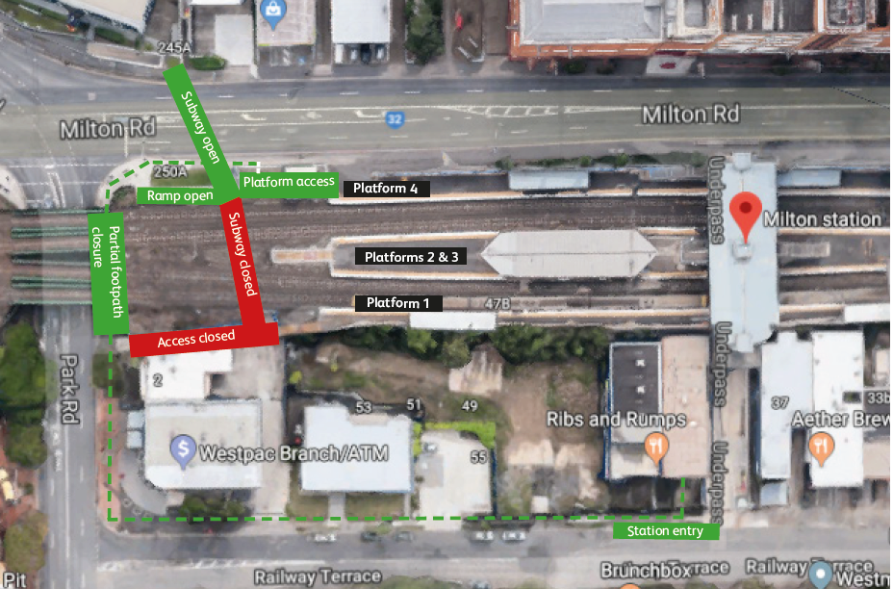

Pedestrian access Map data ©2019 Google

We are moving towards paperless notifications about noise and works. You will still see paper notices as we transition to the new system. Sign up at: queenslandrail.com.au/EmailNotification or contact us if you prefer to receive paper copies.

