North Johnstone River bridge remediation works

March 2016

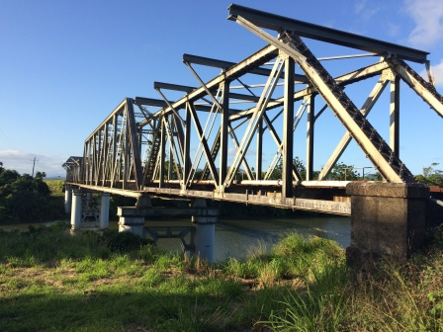
Queensland Rail is undertaking remediation works on the North Johnstone River rail bridge on the North Coast line, approximately one kilometre south of Daradgee. The remediation works are necessary to ensure safe, timely and adequate rail services continue to be provided to the North Coast line between Townsville and Cairns.

Upcoming activities planned for March 2016 are listed in the table below.

Works will generally occur between 6am and 6pm Monday to Saturday, unless specified (for example, scheduled night works).

Overview of work

Approximate date | Activity | Type of work
Ongoing | - Access route maintenance  - Vegetation maintenance  - Scaffolding checking and maintenance | - Bridge inspections  - Slashing  - Vehicle movements  - Delivery and set-out of materials
5 and 8 March | - Preparation for track works | - Moving new rail onto bridge in preparation for replacement  - Heavy vehicle and machinery movements
9-15 March | - Track works on bridge | - Heavy vehicle and machinery movements
14-15 March (including overnight works on 14 March) | - Track works on bridge approaches | - Tower lighting  - Heavy vehicle and machinery movements

Queensland Rail is aware that works of this nature may cause temporary inconvenience to our valued neighbours. Some noise from heavy vehicle movements and rail installation is expected. Every effort will be made to carry out these works with minimal disruption.

Works will be undertaken overnight on Monday 14 March in order to maximise the project team’s access to the track and bridge during a planned track closure. We apologise in advance for any inconvenience this may cause.

For more information about this project, please phone 13 16 17 (between 8am and 5pm, Monday to Friday) or email communityengagement@qr.com.au.

