Graceville station accessibility upgrade

Project update –

July 2016
Upgrade works on the platforms and in the subway are well underway at Graceville station as part of Queensland Rail’s $212 million upgrade program.

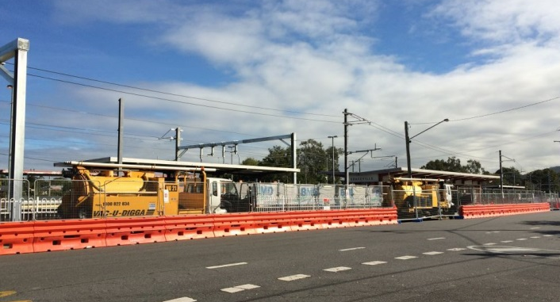

Project progress
The following construction activities were recently completed:
- underground service relocations
- temporary lighting installations
- temporary removal of some platform furniture, lighting, roofing, and signage on platforms 3 and 4.

Upcoming work
In the coming weeks, customers and the community can expect to see the following construction activities:
- preliminary foundation works for new lift shafts
- commencement of excavation for new stairs on platforms 3 and 4
- installation of new conduits and underground service pits.

Track closure
Station upgrade work will be undertaken on the station platforms during a planned track closure from 6am Saturday 30 July to 6am Monday 1 August 2016.

During this time, ticketing equipment will be available and the subway will remain open to pedestrians.

Construction impacts
Customers, residents and businesses adjacent to Graceville station may experience the following:
- noise associated with heavy machinery
- use of reversing beepers
- changed traffic and parking conditions
- mobile lighting towers for night works
- increased vehicle movements around the work zones
- temporary changes to access paths throughout the station precinct.
Pedestrians and motorists are advised to follow all directional signage during this time.
Residents and other stakeholders will be given advance notification of construction activities likely to cause impacts, including after-hours work (nights and Sundays, as required).

Keeping you informed
For more information on this project, please contact the Stakeholder Engagement team on 1800 722 203 (free call), email stationsupgrade@qr.com.au or visit www.queenslandrail.com.au

