Graceville station accessibility upgrade

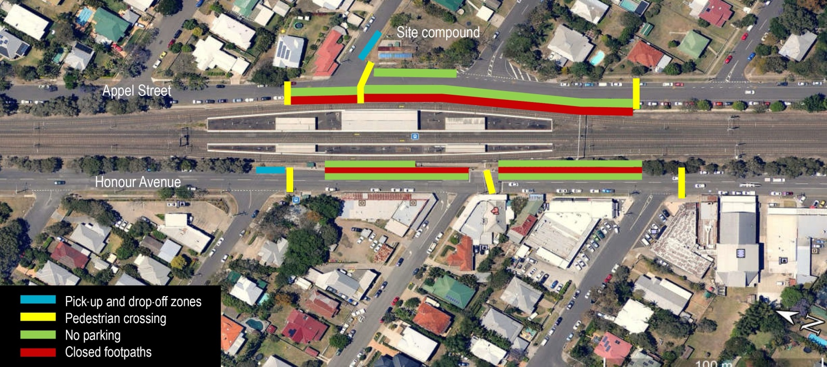
Temporary changes to parking and access

Early work at Graceville station has begun to enable main construction on the platforms to commence. Preparatory and site establishment work will be undertaken on the Queensland Rail land on the corner of Verney Road East, and Appel and Connors Streets throughout April 2016.
As part of site establishment, some temporary changes to on-street parking will be required to enable machinery and materials to be safely stored adjacent to the work sites. The following parking areas will be required throughout construction from Tuesday 26 April 2016:
- Appel Street between Verney Road East and Connors Street adjacent to the site compound
- Appel Street between Verney Road East and Evadne Street adjacent to the rail corridor
- Honour Avenue between Verney Road West and Bank Road adjacent to the station.

A temporary pick-up and drop-off zone will be established on Verney Road East adjacent to the work site. As part of the work, changed pedestrian conditions will occur on Honour Avenue and Appel Street. Pedestrians are asked to follow all directional signage during this time.

Access to private properties and businesses will be maintained at all times. Every effort will be made to minimise disruption to our valued customers and neighbours throughout the upgrade. Queensland Rail apologises for any inconvenience and thanks the local community for their cooperation during these important works.

Keeping you informed
Queensland Rail is committed to keeping stakeholders and the community informed about this project. For more information, please contact the Stakeholder Engagement team on 1800 722 203 (free call), email stationsupgrade@qr.com.au or visit www.queenslandrail.com.au

