Newmarket station accessibility upgrade
Works update – March 2016
Newmarket station has been identified as a priority station to receive an accessibility upgrade, to be undertaken as part of Queensland Rail’s $212 million upgrade program.
In preparation for the commencement of upgrade works at the station, upcoming activities include after hours work to remove the Wilston Road timber footbridge and ongoing temporary platform construction. Works are listed in the table below.

Overview of planned works
Location | Dates and hours of work | Type of work
Temporary platforms (adjacent to station) | - 10pm Sunday 13 to 5am Monday 14 March  - Overnight works | - Ongoing temporary platforms works  - Operation of heavy equipment including cranes and lighting towers  - Use of hand tools and powered equipment  - Vehicle movements
Wilston Road timber footbridge (adjacent to level crossing, Ferny Grove end of station)  See overleaf for more information | - Monday 14 to Thursday 17 March  - 10pm to 5am, each night | - Removal of timber footbridge  - Operation of heavy equipment including cranes and lighting towers  - Removal of bridge sections from site by semi-trailer  - Use of powered tools (jack hammers, saw cutting)  - Reconnection of overhead wires and equipment  - Vehicle movements
Newmarket station | - 10pm to 4am (overnight works) on:  - Sunday 20 March  - Monday 21 March  - Tuesday 22 March  - Wednesday 23 March  and on:  - Monday 28 March  - Tuesday 29 March | - New overhead masts and cantilever modifications  - Use of lighting towers  - Use of heavy, loud machinery including on-track vehicles, trucks and cranes with bright flashing lights and reversing beepers  - Use of hand tools and powered equipment
Heavy machinery and mobile lighting towers will be used during night works. Nearby residents may experience noise from construction activity and truck movements.
Queensland Rail is aware that such operations may cause temporary inconvenience to our valued neighbours. Every effort will be made to carry out these works with minimal disruption.

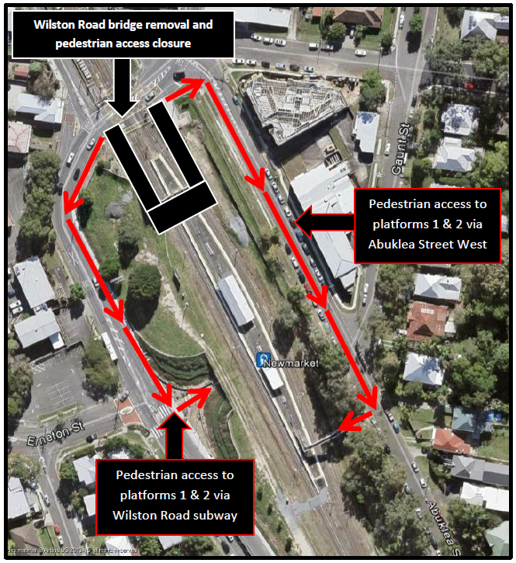
Construction impacts
Throughout construction, changes to station and platform access will be communicated in advance and signage at the station will direct customers accordingly.
Regular working hours for this project will be 6am to 6pm, Monday to Saturday.
Due to the complex nature of the work and the need to maintain ongoing rail services, after hours work will be required in addition to regular daytime activities. Residents and other stakeholders will be given advance notification of construction activities likely to cause impacts, including after hours works (nights and Sundays, if required).
Queensland Rail would like to thank customers and the community for their patience during these important works.
Keeping you informed
Queensland Rail is committed to keeping stakeholders and the community informed about this project. For more information, please contact the Stakeholder Engagement team on 1800 722 203 (free call), email stationsupgrade@qr.com.au or visit www.queenslandrail.com.au

Changes to the station
Newmarket station will remain open for regular services throughout the upgrade.
Pedestrian access to the station from Sunday 13 March 2016 will be via the Wilston Road subway and the Abuklea Street West footbridge while the temporary platforms are constructed. Pedestrians are asked to follow all directional signage during this time.
When complete, the temporary platforms will provide passengers with uninterrupted and safe access to trains while upgrade work is undertaken on the existing station platforms.
As part of the accessibility upgrade a new footbridge and lift will be installed toward the centre of the station.

