Alderley station accessibility upgrade

Access and parking changes – July 2016
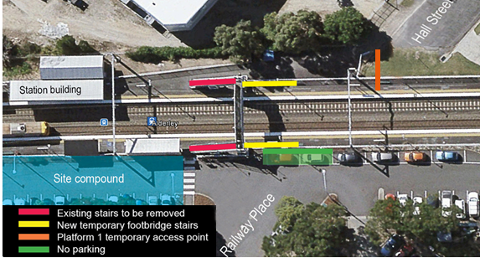

Main construction works on the platforms will commence shortly, with some changes to station access and parking.
To enable excavation work on the lift shafts to begin, the following changes will take place from Monday 11 July 2016:
- works will commence to reconfigure the existing footbridge stairs on both platforms to face the city end of the platforms
- the existing access to platform 1 will be closed and a temporary access point will be established from Hall Street at the city end of the platform
- two car parking spaces, adjacent to platform 2, will be used to accommodate the new stairs and a new temporary access to platform 2.

Full-length platform access will be maintained throughout these works. For your safety, please follow all directional signage and take care around the work zones and changed access points.

Every effort will be made to minimise disruption to our valued customers and neighbours throughout the upgrade. Queensland Rail apologises for any inconvenience and thanks you for your cooperation during these important works.

Keeping you informed
For more information, please contact the Stakeholder Engagement team on 1800 722 203 (free call), email stationsupgrade@qr.com.au or visit www.queenslandrail.com.au

