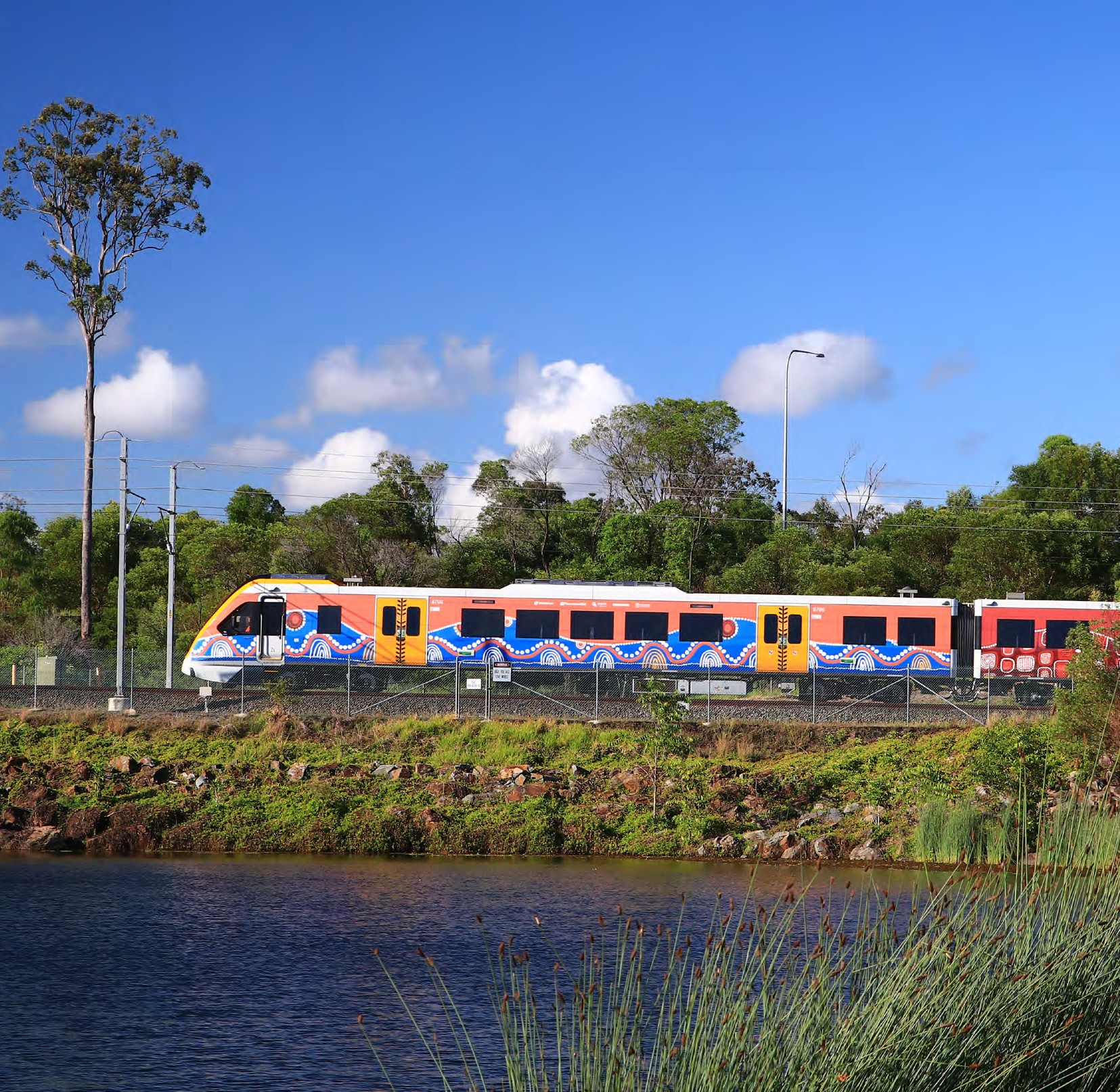

Queensland Rail

Supplier Code of Conduct

Supplier Code of Conduct
Queensland Rail Limited ACN (132 181 090) October 2020

contractual obligations.

Queensland Rail expects suppliers to read, understand and ensure that their business and supply chain meet the expectations set out in our Supplier Code of Conduct. Suppliers must communicate this Code to related entities, suppliers and subcontractors who support them in supplying to Queensland Rail, so that they take reasonable steps to ensure they understand and comply with this code.

Suppliers are expected to proactively self-assess compliance and take action to remedy any shortcomings.
Supplier Code of Conduct
Queensland Rail Limited ACN (132 181 090)
October 2020

Queensland Rail’s goal is to provide a customer focused, safe, reliable, on-time and value for money rail
service that benefits the community, supports industry and is integrated with the public transport system. We recognise our suppliers play a pivotal role in the achievements of these outcomes.
This Supplier Code of Conduct (Code) sets out the expectations that Queensland Rail has of its existing
and future suppliers in the following areas:

- Safety

- Ethical Behaviour

- Labour and Human Rights

- Social Responsibilities

- Environmental Sustainability

- Publicity and Advertising

The expectations in this Code are not intended to alter or override suppliers’ legal, regulatory and

Queensland Rail is committed to ensuring the health and safety of our employees, contractors, customers and visitors. Suppliers must adhere to all Queensland Rail safety requirements whilst on site.

We expect suppliers will:

- Create and maintain a healthy and safe work environment and integrate sound health and safety management practices

- Maintain and monitor a risk management process to identify, manage and control relevant risks associated with their operations

- Ensure their people are fit for work and have the required training and competency for the work being performed

- Consult with relevant parties in relation to the
provision of information and training

- Comply with all relevant national and local safety legislation, including health and safety management reporting

- Participate in industry or Government initiatives that aim to improve workplace health and safety outcomes

- Maintain and monitor appropriate safety policies and procedures

- Keep abreast of changes in work place health
and safety legislation

- Commit their suppliers and sub-contractors to operate with the same standards.
Queensland Rail is committed to doing business with integrity, probity and accountability and expect our suppliers to commit to the same standards.

In particular, we expect our suppliers to:

- Comply with the Ethical Supplier Threshold, as described within the Queensland Procurement Policy 2019 (clause 2.3)

- Offer payment terms to sub-contractors that are no less favorable than those provided to you by Queensland Rail (unless agreed otherwise)

- Meet relevant compliance requirements and the Australian Standard (or international standard where this is no Australian standard) and ensure the use of conforming products and materials.

- Declare all conflicts of interest (whether actual, reasonably perceived or that could arise in future) as soon as possible

- Conduct business activities in a professional, ethical, equitable and transparent manner

- Not engage in any form of corrupt behaviour including extortion, fraud or bribery

- Comply with data privacy, confidentiality and regulatory requirements in relation to data and information

- Mitigate risks and safeguard people, brand, reputation, assets, premises and resources

- Commit their suppliers and sub-contractors to
operate with the same standards.

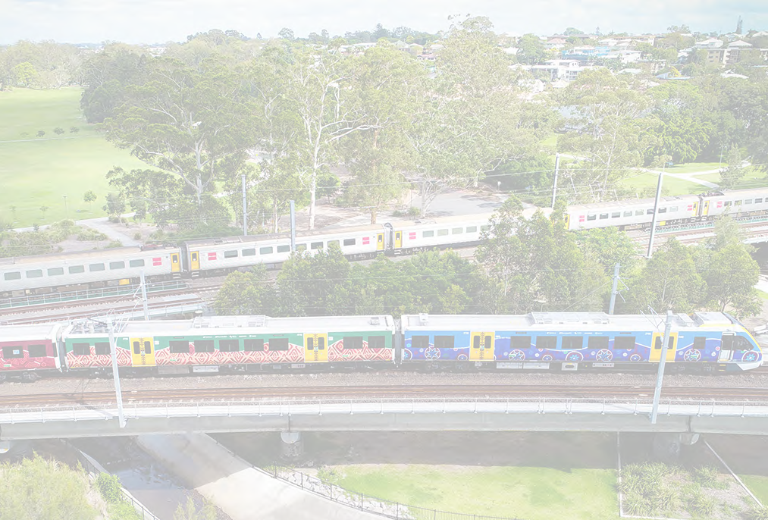

Supplier Code of Conduct
Queensland Rail Limited ACN (132 181 090) October 2020

Human Rights Social Responsibilities

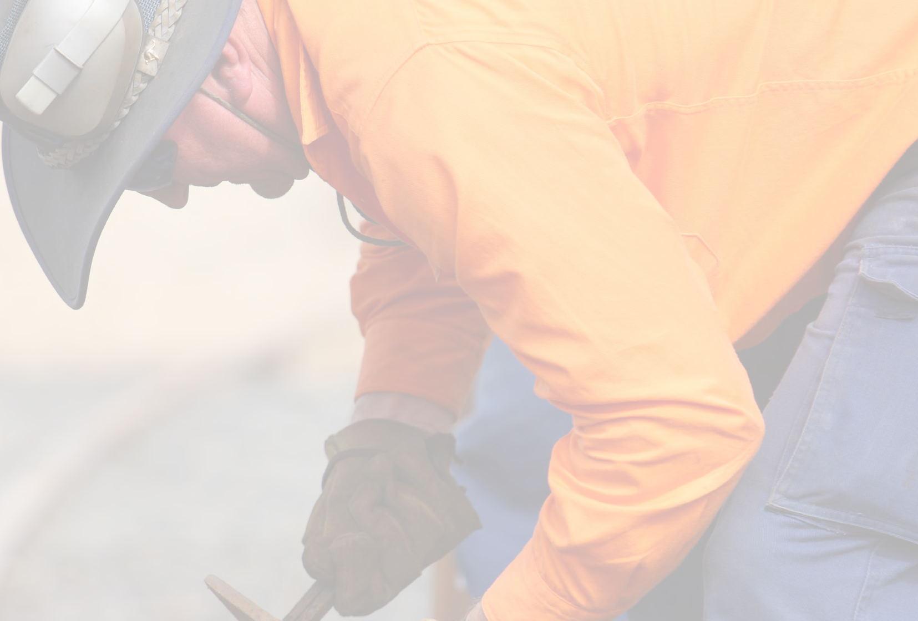Queensland Rail is committed to ensuring human rights abuses, such as modern slavery do not occur in our supply chains.
•
Provide an equal opportunity workplace that is non-discriminatory, diverse, inclusive and respectful, and free from harassment and abuse
•
Respect all workers’ workplace rights and entitlements, and comply with all relevant workplace laws and regulations
•
Provide fair pay for employees, including meeting minimum wage requirements and compensation
•
Comply with all applicable laws related to wages, employment conditions, working hours and legally mandated benefits in relation to the country in which they operate
•
Commit their suppliers and sub-contractors to operate with the same standards.
Supplier Code of Conduct
Queensland Rail Limited ACN (132 181 090)
October 2020

We expect suppliers will:

- Conduct their activities in a manner that respects human rights, as set out in the Queensland Human Rights Act

- Not use forced, bonded, involuntary labour or child labour

- Declare in a timely manner to us any known risks that may exist within their supply chain that may contribute to Modern Slavery

- Have an avenue in place in which anyone can report concerns about illegal, unethical or improper conduct associated with the supplier’s business
Queensland Rail is committed to doing business with suppliers who support the welfare of both their employees and the community.

We expect suppliers will:

- Be aware of cultural heritage and traditions of Indigenous communities and that all matters be handled respectfully

- Promote work practices that create
opportunities for inclusion and diversity

- Show a zero-tolerance approach to domestic
and family violence

- Conduct business in a way that builds good relationships and achieves a positive impact on the local communities in which they operate

- Commit their suppliers and sub-contractors to operate with the same standards.

Sustainability Advertising

Queensland Rail is committed to reducing the impact of its operations and that of its supply chain on the environment.

We expect our suppliers to:

- Comply with and keep abreast of all relevant laws and regulations relating to the environment

- Consider the impact of their goods and or services on the environment

- Effectively assess and mitigate environmental risks

- Progressively look for opportunities to improve environmental outcomes and reduce environmental impacts

- Commit their suppliers and sub-contractors to operate with the same standards.
We expect suppliers will not, without our prior written consent:
- Use Queensland Rail’s name or logo in publicity or advertising

- Make representations or statements for or on behalf of Queensland Rail

We expect suppliers will commit their suppliers and sub-contractors to operate with the same standards.

How to deal with incidents or suspected breaches of the Code

Concerns regarding breaches of this Code should be directed to:

Option 1: For Supplier Code of Conduct related issues, complaints or questions please contact the Queensland Rail Ethics and Integrity team at Ethics@qr.com.au or qr@stopline.com.au
Option 2: Any concerns regarding illegal activity or corruption should be immediately referred to either the
Queensland Police Service or the Crime and Corruption Commission. Concerns regarding breaches of regulation should be referred to the relevant regulatory body

