Filename: X:\GIS_Requests\MAPPING\_QR_GIS_PROJECTS\2010\Statewide\Network_Control_Boundaries\Project\ODRL_Network_Control_Regions_03-03-2016.mxd

Normanton

Croydon
Forsayth

Almaden

Mareeba
Cairns


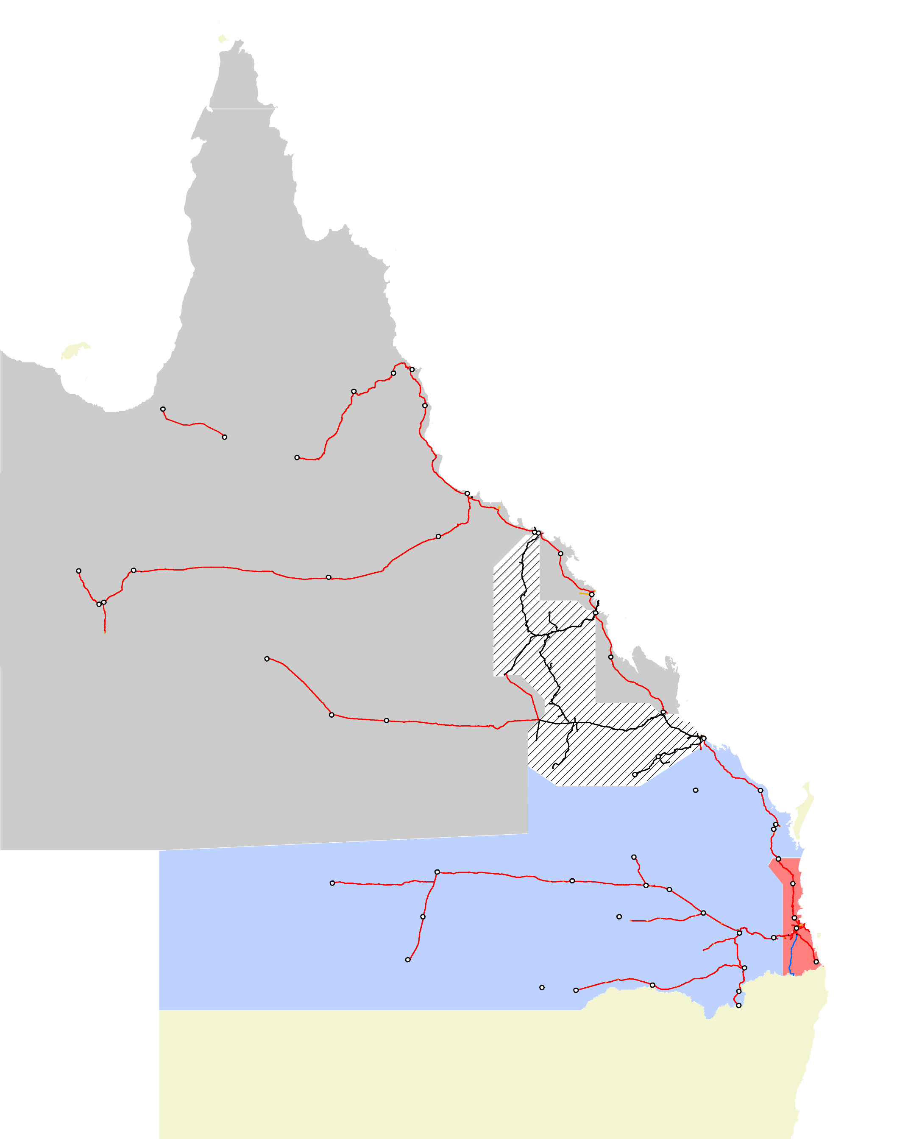
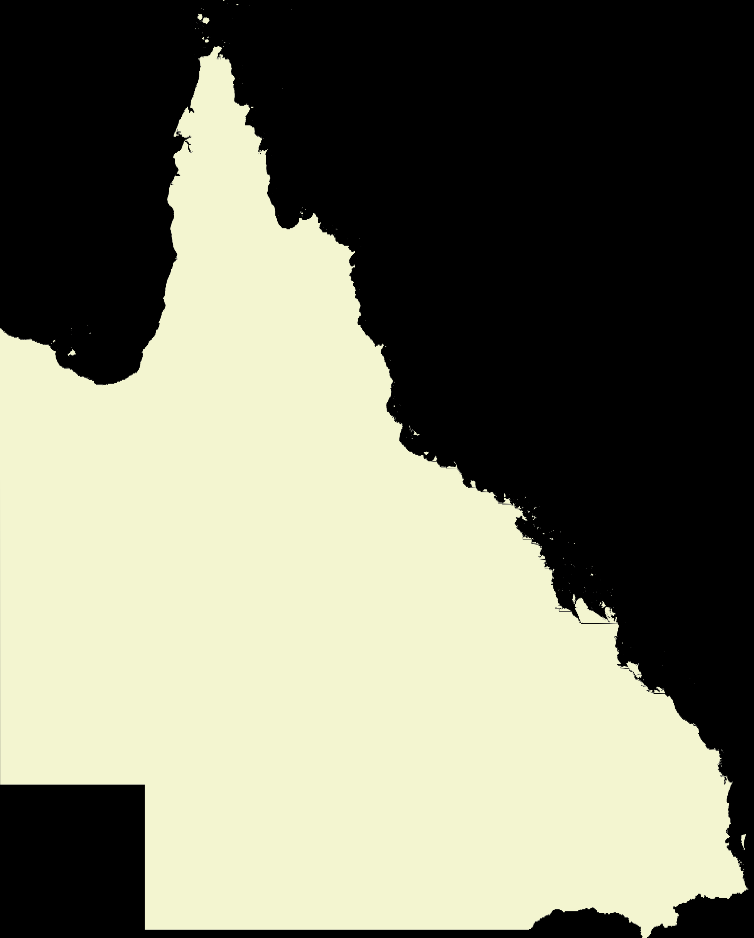
Innisfail
Effective 09-11-15

!(

TOWNSVILLE
Regional Transit Manager QR 84-1207
Public 07 4772 8207

TOWNSVILLE

Mount Isa

Cloncurry

Hughenden
Charters Towers

Kaili Collinsville
Durroburra

Proserpine

Duchess

Flynn

Mackay

Yukan

Winton
Coppabella

St Lawrence

Longreach

Barcaldine

Emerald

Rolleston
!(

Earlsfield Moura

ROCKHAMPTON

Parana

Monto
Bundaberg

Quilpie

Charleville

Roma

Wandoan Miles
Chinchilla
Maryborough West
Mungar Gympie North
Nambour

RAIL CENTRE 1

Wyandra

Glenmorgan
Dalby Petrie
(!(!jk

Regional Transit Manager QR 81-1662
Public 07 3235-1662

Cunnamulla
Toowoomba
kj

Warwick
MAYNE
RAIL CENTRE 1
Varsity Lakes

Dirranbandi

Thallon

Goondiwindi
Stanthorpe Wallangarra

MAYNE
Network Control Supervisor QR 85-5970
Public 07 3606 5970


Queensland Rail Limited does not warrant the accuracy or completeness of information displayed in this map and any person using it does so at their own risk. Queensland Rail Limited shall bear no responsibility or liability for any errors, faults, defects, or omissions in the information. This drawing is for the exclusive use of the persons to whom it was originally distributed and is not to be disseminated, copied or distributed by any other party.
0
85,000170,000
340,000
Legend
Metres
1:6,723,564(when printed at A3)
© 2016, Queensland Rail Limited
© 2016, State of Queensland, DERM
© 2016, PB MapInfo Corporation
´
!(
Network Control Centres COMPANY
Data Sources:
Stations
jkSignalling Centres
ARTC
AURIZON
PRIVATE
QUEENSLAND RAIL
Aurizon Network Mayne [BSA]
Townsville
RC1Control
OVER DIMENSIONAL
ROAD LOADS NETWORK CONTROL REGIONS
CREATED BYJPL - BPR0003 LAST MODIFIED JPL - 03 MAR 2016
A3 size

