
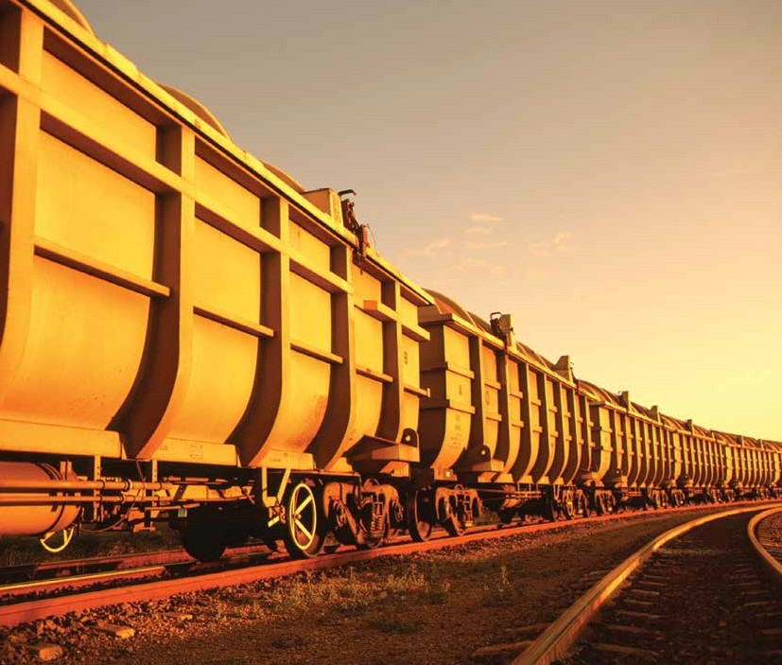
Mount Isa Line Rail Infrastructure Master Plan

2012

I am proud to present the Queensland Rail Mount Isa Line Infrastructure Master Plan 2012 to our customers, industry, government and other stakeholders.

The Mount Isa Line is unique. Unique in its history, unique in its operating characteristics and unique in its unprecedented potential.

Significant new mineral deposits coupled with the discovery of
coal in the Northern Galilee Basin indicates that the Mount Isa Line is on the cusp of exponential growth opportunities. Queensland Rail
is committed to transporting the forecast tonnage anticipated to be railed on the Mount Isa Line.

It’s not only the Mount Isa Line
that is changing; Queensland Rail is transforming too.

During 2011, Queensland Rail was awarded International Customer Service Standard recognition.
Queensland Rail is now the first fully integrated rail transport company in the world to achieve this certification. Our customers are our absolute priority.

We remain committed to developing the company from its previous asset based focus to a fundamentally customer centric operation. As
the asset manager of the Mount Isa Line, Queensland Rail is not only in the business of providing access to our network. We have the expertise to design, construct,
maintain and manage any network configuration deemed necessary by our customers.

We are working closely with our customers to understand their individual markets and growth opportunities and we will be there to help grow and improve their business. The current and future needs of our customers remain our key priority.
We are focused on continuing our proud history within the region. We will continue to support the communities along the Mount Isa
Line and remain a dominant driver of economic activity in North and North West Queensland.

Jim Benstead
A/Chief Executive Officer


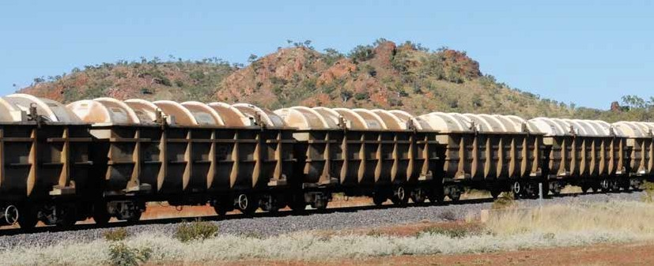

Exciting opportunities

The Mount Isa Line is 1032 kilometres of track which extends from Stuart (near Townsville)
to Mount Isa and includes the Phosphate Hill branch. The line services a number of communities along the line through passenger transport, the conveyance of
general freight and remains a major employer along the corridor. The
line is the critical link from the North
West Minerals Province to the Port of Townsville where the majority of bulk products
are exported.

The Mount Isa Line is of particular national interest as it runs along some of the world’s largest deposits of copper, lead, zinc, silver and phosphate rock. The region surrounding the Mount Isa Line produces 75% of Queensland’s
non-coal mineral output. As a result of strong international demand for commodities, exploration in the North West Minerals Province has
increased significantly in recent years.
Current interest in developing substantial coal deposits in the Northern Galilee Basin underwrite the unprecedented growth opportunities for the Mount Isa Line. These opportunities will ensure the region continues to make significant ongoing contributions to the local, state and national economies.

The Queensland Rail Mount Isa
Line Rail Infrastructure Master Plan
2012 aims to clarify our strategic planning for specified growth scenarios to assist customers, regional and local planning bodies and other stakeholders in
preparing and developing their own development strategies. The plan presents options to enhance the capacity of the system to cater for base, medium and high tonnage growth scenarios.

Whilst it is difficult to forecast the success of potential mining ventures, Queensland Rail has undertaken significant analysis
to develop three potential growth
scenarios and to provide a broad
vision of the rail infrastructure required to underpin the forecast growth. Capital investment estimates have been determined to provide a basis for planning.
Indicative timelines for construction have similarly been included.

Queensland Rail is confident of the potential of the Mount Isa Line. The base case forecast growth scenario sees an increase to approximately 8 mtpa on the system; a 43% increase from current levels.

Queensland Rail is focused on being an active supply chain partner
to assist our customers to grow and improve their business, whilst providing a safe and reliable network for the passage of bulk goods to the Port of Townsville and beyond.

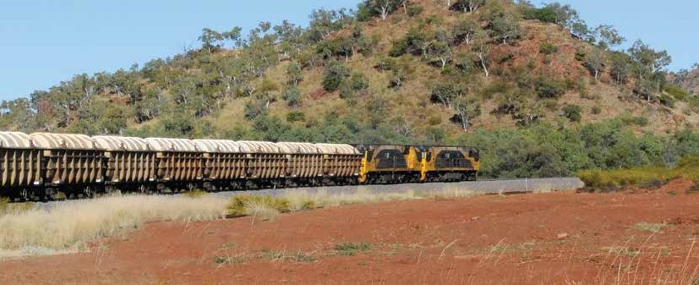

3

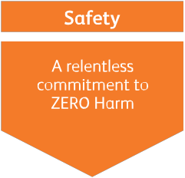

A new era
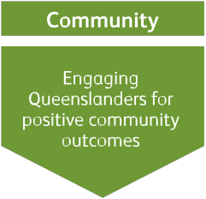



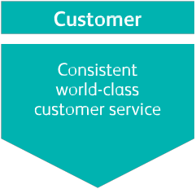

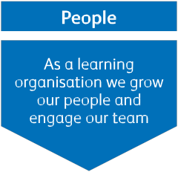

On 1 July 2010, Queensland Rail Limited was established as an integrated passenger and rail infrastructure business servicing the passenger, tourism, resources and freight markets.

Although Queensland Rail is a new organisation, it has more than
145 years of history and over that time has become an irreplaceable part of communities throughout Queensland. Queensland Rail
has played a major role in the state, providing the backbone
for economic, social and regional development across Queensland. Strengthening these links and supporting the growing state of Queensland is a core focus of the new Queensland Rail.

Underpinning the business strategy are the five pillars of Safety, Customer, People, Commercial and Community.
Safety: Safety remains Queensland Rail’s top priority, focusing on strengthening the safety culture within the organisation and the systems and processes that support it. Queensland Rail is focused on maintaining Zero Harm for all employees, customers and the general public.

Customer: Queensland Rail is dedicated to working with our customers to meet and exceed their expectations. We are forming close relationships with customers to understand individual markets,
key drivers and the growth potential of businesses. Queensland Rail
is focused on helping to grow and improve the business of our customers.
People: We recognise that our people are our greatest asset. Queensland Rail is an accountable organisation fostering a high performance culture through encouraging and growing talent and providing continuous learning opportunities.
Commercial: The commercial objective centres on building a sound foundation for Queensland Rail’s governance frameworks, systems and processes and providing a financial return for the state of Queensland. Historically, Queensland Rail has provided
the necessary funded capital enhancement to the Mount Isa Line to ensure available capacity exists for market growth. This is a strategy we aim to continue.

Community: As the only rail passenger transport provider in Queensland and manager of more than 7000 kilometres of the state’s rail networks, Queensland Rail plays a role in almost every Queensland community. Queensland Rail will partner with the community to strengthen its ties with the people of Queensland and make a true difference in their lives.



the

of Queensland

4

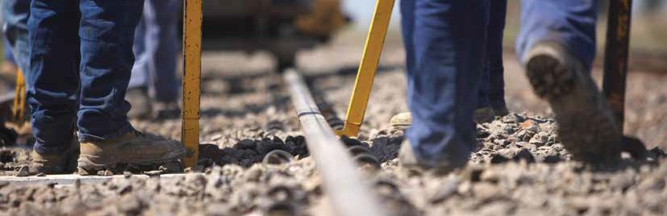

A new focus

In October 2011, Queensland Rail became the first fully integrated
rail transport company in the world to achieve International Customer Service Standard certification. As an International Customer Service Certified organisation, Queensland Rail’s strong and committed efforts
continue to transform the company from its previous asset based focus to a fundamentally customer
centric orientation.

Our customers needs are our absolute priority. Queensland Rail will continue to focus on improving customer service levels which will translate into more tonnes on the Mount Isa Line and a better return for the state of Queensland.

Regulatory environment It is important to note the regulatory environment in which we operate. Queensland Rail, as
one of the monopoly owners of rail lines in Queensland, has obligations
under legislation and is regulated by the Queensland Competition Authority. This includes Queensland Rail providing open and transparent access to its rail network for operators, which includes access to the Mount Isa Line.

Queensland Rail is operating under the QR Network Access Undertaking (2008) June 2010 which provides guidance for access seekers looking to obtain access to the Queensland Rail network. Queensland Rail is
in the process of preparing a new voluntary Draft Access Undertaking which is expected to be finalised and replace the current Access Undertaking during the second half of 2012.

All rail operators must have a valid Access Agreement with Queensland Rail in order to operate on the Queensland Rail network. The Mount Isa Line now has
three accredited rail operators: QR National, Pacific National
Queensland and Queensland Rail.
As Queensland Rail’s constitution precludes it from running a registered freight rail operation (we are only registered as a passenger operator), we are able to maintain competitive neutrality for all operators on the Mount Isa Line.

Queensland Rail looks forward to the continued growth of the line and potentially the introduction of more customers to this diverse and prosperous region.


5

Fast facts:

Asset replacement value: $12.8 billion
Length: 1032 km |  | Current tonnages railed: 5.8mtpa
Rail: 41, 47, 50, 53 and  60kg/m |  | Gauge: Narrow
Axle load: 20 tonne |  | Mainline sleepers: Concrete 75%; Steel 25%
Maximum line speed: 80km/hr |  | Max train length 1000m
Safeworking system: | Direct Traffic Control | Train Control Centre: Townsville
Regional mineral production: | AUD $6.67 billion | Maintenance personnel: 115
Seasonal considerations: | Extreme heat and heavy monsoonal rains during the summer months
Products railed: | Copper Sulphuric acid General freight | Lead Zinc Magnetite Cement Livestock Sulphur Fertiliser Passengers

Recent enhancements

Queensland Rail continues to explore ways of using technology to further improve the reliability of the Mount Isa Line. Since the release of the 2009 Infrastructure Master Plan, Queensland Rail has achieved the following safety and performance enhancements:

Installation of concrete sleepers An additional 64km of concrete resleepering has been completed between Rifle Creek–Mount Isa; Malbon–Bungalien and Julia Creek– Undina. This work continues the upgrade to concrete sleepers in
the more challenging areas which
are complicated through difficult geographic conditions coupled with the isolation of the area.

Automated Geometry
Measuring System
The AGMS is an unmanned track recording machine incorporated
into a train consist which completes a weekly assessment of the track. The machine measures the track geometry and the profile of the rail whilst also capturing video of the rail. The data captured is transferred back to Network Regional engineers via the 3G network for analysis. The system additionally sends out alerts such as high priority defects to field
staff that require urgent attention.
Weather monitoring stations
A total of 23 weather monitoring stations have been installed along the Mount Isa Corridor in locations historically impacted by seasonal flooding. These provide critical real time information on temperature, rainfall and the height of rising water around the fixed infrastructure.
Alerts are sent to both field staff and the Townsville Control Centre as a warning for increased monitoring. This comprehensive data is now being shared with the Bureau of Meteorology to assist with weather monitoring and seasonal modelling.

6

Hot Box detectors have been installed at Rifle Creek and Tibarri. These provide a simultaneous alarm to the train driver and Townsville Control Centre that detect bearings on rollingstock that are projecting heat and noise signatures outside normal operating parameters. This
is an indicator of potential failure, allowing intervention by train drivers and train control to reduce the risk
of bearing failure and derailments. By The Mount Isa Rail Corridor identifying defective components on rollingstock we can proactively
reduce the cause of derailments,
delays to services or damage
to below rail infrastructure and rollingstock.

Overload detectors
Queensland Rail is currently trialling high speed overload detectors
at Pymurra and Rifle Creek. The detectors monitor the weight of individual wagons and additionally highlight any loading irregularities which can increase the risk of derailments and have serious safety consequences for both the rail operator and the network.
Level crossing upgrades
Level crossings on the Mount Isa Line have been upgraded with the installation of flashing lights and boom gates at Malbon and Mount Isa. These upgrades were
part of Queensland Rail’s strategic safety pillar, ensuring the safety
of its people, customers and the community.

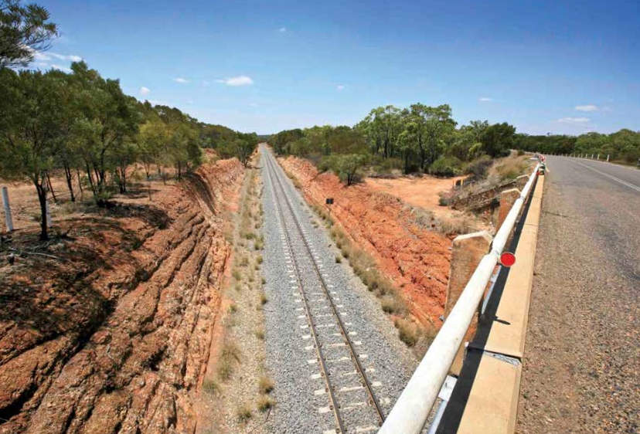

7



QR National is the largest rail freight haulage operator in Australia by tonnes hauled, operating in key freight sectors and supply chains across the country.




QR National is focused primarily
on large, heavy haul rail tasks such as the transportation of coal, iron ore, other minerals, agricultural products and general freight as well as containerised freight.

GPO Box 456
Brisbane QLD 4001
Telephone: 13 23 32 qrnational.com.au
Pacific National is Australia’s largest private rail freight business. Operating in all states and the Northern Territory, Pacific National is a transport leader, delivering investment, innovation and growth in rail to provide the competitive answer for transport customers.

Pacific National is fully owned by the Australian Stock Exchange listed entity Asciano.

PO Box 95
Stones Corner
Brisbane QLD 4120
Telephone: +61 7 3426 5800 pacificnational.com.au
Queensland Rail is the state’s number one passenger service provider, carrying more than 55 million passengers a year and connecting people and destinations throughout Queensland.

The Inlander passenger service runs from Townsville to Mount Isa twice every week.

Queensland Rail Travel
PO BOX 1429
Brisbane QLD 4001
Telephone: 1800 872 467 queenslandrail.com.au

8

A region of possibilities

Following favourable increases to commodity prices, exploration in the North West and North East Mineral Provinces has significantly increased.

Sizeable deposits are being identified that will potentially add considerable additional tonnages to the Mount Isa Line. These products include phosphate rock, copper,
lead, zinc and sulphur.

Minerals are currently the key product transported on the
Mount Isa Line and expansions of
existing mines and development of additional deposits are likely in the future. Exciting opportunities in the Northern Galilee Basin are also emerging with interest developing in significant coal deposits. Coal haulage by rail may fundamentally
change the operations of the Mount
Isa Line.

Whilst it is difficult to forecast the success of potential mining ventures, Queensland Rail has undertaken significant analysis
to develop three potential growth scenarios and to provide a broad
vision of the rail infrastructure
required to underpin the forecast growth. Capital investment estimates have been determined and indicative timeframes for construction have similarly been included.

The development potential for the Mount Isa Line is enormous. The Base Case growth scenario represents a 43% increase on current tonnages on the network.
Queensland Rail is keen to work with prospective customers with a view
to increasing tonnages transported on the Mount Isa Line.

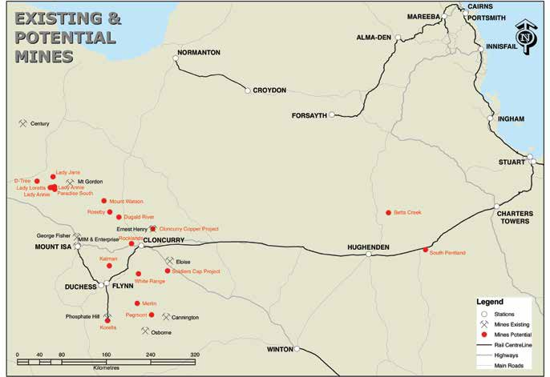

9

The rail perspective
Corridor
 | Stuart to  Hughenden | Hughenden to Cloncurry | Cloncurry to Flynn | Flynn to  Mount Isa | Flynn to Phosphate Hill
Current usage (mtpa) | 4.7 | 4.7 | 2.9 | 2.7 | 2.1

The static method used to calculate contractible capacity in the
previous Mount Isa System Rail
Infrastructure Master Plan 2009 has been retained for this plan.

On a single track corridor such as the Mount Isa Line, Queensland Rail uses a simple principle that theoretical capacity on a given day
is calculated by the total number of minutes in the day divided by the longest sectional run time.

This theoretical calculation implies continuous occupation of the longest section, which in reality is unsustainable. Other factors need to be taken into consideration to
provide a more practical calculation of capacity. Queensland Rail applies a reduction factor of 30% to the theoretical capacity to take into account operational issues such as safeworking requirements, speed restrictions, different train types
and transit times. A maintenance allowance of four hours per day
is also applied to ensure the appropriate time is allocated to maintenance activities which are necessary for the continued
reliability and safe operation of the network.

The 2012 Mount Isa Line Master Plan provides an additional capacity analysis by individual corridor from the 2009 Plan. This reflects that
not all traffic on the Mount Isa Line traverses the entire line from Mount
Isa to Townsville.

There is currently capacity available on the line for the contracted tonnes. Whilst capital investment may not be required for a slight increase in tonnes, any growth from current levels will be accompanied with increased maintenance costs
to cover the impact of additional tonnages on the network. This increase in maintenance will be recovered through access charges.

Historically, Queensland Rail has provided timely capacity enhancements to aid the growth in tonnages on the Mount Isa Corridor. In the future, capacity enhancements will continue to
be delivered for future projects provided that contracted tonnages:
• are sufficient to justify the necessary investment on commercial terms
• adequate notice is given from the time of contracting capacity to deliver the required enhancements.

To ensure that capacity and track condition is appropriate to accommodate demand for new projects, Queensland Rail
encourages rail operators, mining companies and/or processors to engage with Queensland Rail at the earliest possible opportunity. This will allow sufficient time to work through detailed capacity analysis and to determine the capacity
and network upgrades necessary and negotiate all commercial agreements including an access agreement.

Queensland Rail acknowledges that operational capacity is an output
of the interaction between rail track infrastructure and our customers’ rollingstock. We are encouraged
by the recent capital investment our customers are making in their businesses and are excited by the new generation rollingstock being developed by global manufacturers. Ensuring our infrastructure can
meet technological enhancements in rollingstock design will remain a central pillar of business strategy into the future.

10

Ensuring a safe and reliable network

Maintaining the network in a fit, safe and reliable state is a safety priority for Queensland Rail. Maintenance costs have been included in all growth scenarios as any significant increase in tonnes will translate into higher maintenance requirements.
These costs will be funded through access charges. Queensland Rail has developed a planned program to upgrade infrastructure on the Mount Isa Line to increase the long term stability of the network which includes:
• Replacing steel sleepers with concrete sleepers
• Replacing light rail with heavy rail
(60kg/m).

At present there is 380km of track with 41kg/m or 47kg/m rail on
steel sleepers remaining, consisting of 116km in crossing loops and
264km on open track which need to be addressed. Queensland Rail aims to continue the resleepering and rerailing to complete the transformation of the entire system to concrete sleepers and heavier rail.

The current timing of the program is dependant on sufficient growth
occurring on the line to provide the additional funding for these works. Should significant additional tonnes be contracted on the network,
the works program will need to be accelerated to coincide with the increased traffic.

“Transportation Technology Centre Inc considers the current level of track maintenance adequate for the current duty. Evidence for this is the consistently good track geometry
for several years and the control being shown over speed restrictions and track buckles.”
(extract from ‘Mount Isa Line Review’ P-10-036. Prepared by John Tunna, Transportation Technology Centre, Inc. A subsidiary of the Association of American Railroads, Pueblo, Colorado, USA. Sep 8 2010.)

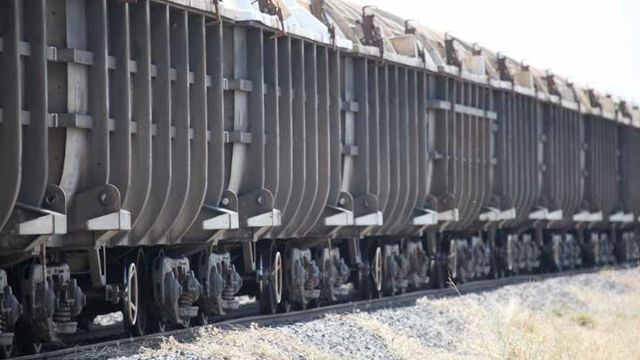

11

Unlocking the potential

Developing tonnage forecasts for 60 the future is difficult and reflects 50 the challenges of precise calculation
Million tonnes per annum
of mine start timeframes and 40
fluctuation in demand arising
from global commodity prices. 30
There are many methodologies,
trends and assumptions that 20
may be valid in the short term. 10
However fundamental shifts in
the market may quickly make 0
such approaches invalid.
Mount Isa Line growth scenarios

2011/12
Time

High

Medium

Base

The 2009 Master Plan identified three growth scenarios: 7.8 mtpa, 12.5 mtpa and 20 mtpa.
Queensland Rail has redeveloped the series of traffic flow scenarios on the anticipated and potential outputs from various mining
and processing projects in the region. Due to the discovery and subsequent proving of coal reserves in the Galilee Basin, the high growth scenario from 2009 (20 mtpa) now constitutes the medium growth scenario for 2012. The high growth scenario in 2012 sees in excess of
50 mtpa moving along the Mount
Isa Line.

The Stuart to Hughenden corridor has the greatest potential for growth with the discovery of coal deposits in the Galilee Basin. These
developments will deliver significant tonnage growth on the corridor requiring considerable capacity and network upgrades.

Base Case: 8 mtpa

The base case scenario seeks
to provide the capacity needed to accommodate a reasonable projection of growth whilst ensuring the sustained reliability of the network.

This scenario overlays the current traffic with anticipated changes to:
• Increased copper concentrates from Cloncurry and Mount Isa
• Increased zinc concentrates from
Mount Isa

• Alterations to acid and sulphur tonnage flows across the corridor.

The Base Case constitutes a realistic scenario of business as usual
with the continued operation of rail freight and bulk haulage into the Port of Townsville along the
existing rail corridor. A minimal level of investment will be required to increase the capacity of the line.

Capacity enhancements
An increase to approximately
8 mtpa will require a small amount of user funded capacity enhancements. These include additional crossing loops and holding roads. Depending on the traffic task, tonnage level and load location, approximately two new crossing loops for 1000m trains and four new holding roads will
be required. This increase affords improvements to not only capacity, but improved cycle times and operational flexibility.
Crossing Loop: $5.6 million per loop

Holding Road: $5.2 million per road

Operational improvements
In order to transport 8 mtpa along the Mount Isa Line, Queensland Rail will be working with rail operators
to facilitate the operation of longer trains to approximately 1000
metres where possible. The increase in tonnages able to be hauled on current train paths will provide the potential for an increase in system
capacity from the same number of

12

available train paths.

Network condition upgrades The Mount Isa Line in its present configuration is suitable for the current traffic task. To almost double the current railing on the line to
8mtpa would require an upgrade to some parts of the line. This includes replacing steel sleepers to concrete sleepers and replacing all 41kg/m rail to a heavy duty 60kg/m rail.
• Resleepering: $1.05 million per km

• Rerailing: $0.7 million per km

There is currently 380km of steel sleepers remaining (including crossing loops) on the network. Any upgrades to the current structure would be user funded investment. Medium growth
scenario: 20 mtpa

Significant reserves of coal have been confirmed in the Northern Galilee Basin and the Medium Growth Scenario introduces a conservative initial railing of 10 mtpa of coal between Hughenden and Stuart. This increases the tonnage level to almost four
times the current volume on the Mount Isa Line. At this heightened tonnage level, coal trains have been modelled as longer trains (nominally
1500m).

The Medium Growth Scenario also includes increases in:
• Copper concentrates from
Cloncurry

• Phosphate Rock from Mount Isa

• Sulphur from Townsville.
Capacity enhancements Significant capacity enhancements would be required between
Stuart and Hughenden (the potential loading point for coal). All enhancements would be user based investment. Depending on
customer requirements, duplicating a significant portion of the line between Hughenden and Stuart may be more economical than installing individual crossing loops. The optimal capacity configuration will be established with customers
once all requirements and operating parameters are confirmed. Existing crossing loops would need to be extended to cater for 1500m trains.
• Extension of Crossing Loop to
1500m: $2.1 million per crossing loop
• 1500m Crossing Loop: $7 million

• Duplication of Line:
$3.5–$6 million per km

Queensland Rail will consult with customers on capacity enhancements for their individual projects to ensure these align with business requirements and maintain or improve supply chain efficiencies.

Operational improvements
At increased tonnages, Queensland
Rail will investigate the use of:

• New Generation Rollingstock – including increased locomotive performance and electronically controlled pneumatic (ECP) braking as a standard specification in access agreements
• Contractual alignment to performance
• Reconfiguration of network; with an evolving form of train management system to improve cycle times and the efficiency of operations. Any investment would be funded by the access seeker
on the basis of the cost savings from more efficient operations being greater than the cost of the reconfiguration.

Network condition upgrade A substantial increase in the maintenance program would also be required to maintain the reliability
of the track at this heightened tonnage level.

Additional considerations
A significant increase in traffic (>10 mtpa) on the Mount Isa Line to
the Port of Townsville will increase commuter traffic congestion around the Townsville City Centre. At this point, the Townsville Eastern Access Corridor would be required to redirect the Mount Isa Line services to the dedicated rail corridor for uninterrupted access to the Port of Townsville, relieving impacts on the numerous level crossings within the city centre.

13

High growth scenario:
50+ mtpa

The high growth scenario builds on the medium growth assumptions and includes:
• 30+ mtpa of coal from Hughenden

• 5 mtpa of additional product from
Cloncurry

• 3 mtpa of additional product from/to Phosphate Hill.

At this tonnage level, Queensland Rail would undertake a detailed collaborative consultation with customers to determine the best fit for operations and tonnage flows. This would include full alignment with supply chain partners.
Potential suggestions may include:
• Full duplication of line between
Hughenden and Stuart

• Introduction of new train control technologies
• Construction of a dedicated coal corridor between Charters Towers and Kaili (for access to the Abbot Point Coal Terminal).

Queensland Rail will work with customers to design, construct, maintain and manage any network configuration, built to satisfy their requirements and maximise the efficient tonnage throughput of
the line.

Queensland Rail is keen to capitalise on the growth of the Mount Isa Corridor and will provide the
capacity and network upgrades for any realistic demand requirements given sufficient funding and adequate time to deliver the enhancements.

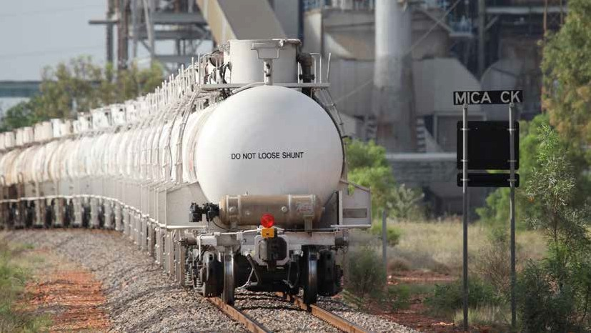

14

Indicative capacity enhancements, costings and timeframes

Growth scenarios | Corridor
 | Stuart–Hughenden | Hughenden–Cloncurry | Cloncurry–Flynn | Flynn–Mount Isa | Flynn–Phosphate Hill
Base case
Tonnes (mtpa) | 7.8 | 7.8 | 5 | 2.5 | 3
Capital enhancements required | 2 crossing loops;  2 holding roads | 2 holding roads | - | - | -
Indicative capital cost | $22m | $11m | - | - | -
Construction timeframe | 18 months | 18 months | - | - | -
Maintenance requirements | Resleepering/ rerailing;  bridge upgrades | Resleepering/ rerailing;  bridge upgrades | Resleepering/rerailing | Resleepering/rerailing | -
Indicative cost | $67m | $354m | $27m | $6m | -
Construction timeframe | 2 years | 5 years | 18 months | 12 months | -
Total cost | $89m | $365m | $27m | $6m | -
Medium growth (includes costs from the base case) All access to the Port of Townsville is through the Eastern Access Corridor.
Tonnes (mtpa) | 20.9 | 10.9 | 7.8 | 5.3 | 3
Capital enhancements required | Duplicate 60km  4 holding roads  Extend all crossing loops | 2 crossing loops  2 holding roads  Extend all crossing loops | Extend all crossing loops | Extend all crossing loops | Extend all crossing loops
Indicative capital cost | $395m | $55m | $6m | $4m | $2m
Construction timeframe | 3 years | 3 years | 18 months | 18 months | 18 months
Maintenance requirements | Resleepering/rerailing | Resleepering/rerailing; Bridge upgrades | Resleepering/rerailing | Resleepering/rerailing | Safety improvements
Indicative cost | $236m | $463m | $119m | $11m | $8m
Construction timeframe | 3 years | 5 years | 2 years | 12 months | 12 months
Total cost | $631m | $518m | $125m | $15m | $8m
High growth (includes costs from the medium growth and base case)
Tonnes (mtpa) | 49.2 | 19.2 | 11.1 | 5.3 | 3
Capital enhancements required | To be determined by customer requirements | To be determined by customer requirements | 2 crossing loops | - | -
Indicative capital cost | To be determined by customer requirements | To be determined by customer requirements | $17m | $4m | $2m
Construction timeframe | To be determined by customer requirements | To be determined by customer requirements | 18 months | - | -
Maintenance requirements | To be determined by customer requirements | To be determined by customer requirements | Resleepering/ rerailing | Resleepering/ rerailing | Safety improvements
Indicative cost | To be determined by customer requirements | To be determined by customer requirements | $137m | $34m | $9m
Construction timeframe | To be determined by customer requirements | To be determined by customer requirements | 2 years | 12 months | 12 months
Total cost | TBD | TBD | $153m | $38m | $11m

Information provided in the growth scenario table does not constitute a commitment by Queensland Rail to complete these works. The suggested improvements are based on detailed capacity analysis with set operating assumptions undertaken by Queensland Rail. Any infrastructure alterations will be determined with customers once all requirements and operating parameters are confirmed for any tonnage increase. Queensland Rail will design, construct, maintain and/or manage any network configuration, built to satisfy customer requirements and maximise the efficient tonnage throughput of the line. We encourage open and transparent dialogue with our customers to ensure this is achieved.

15
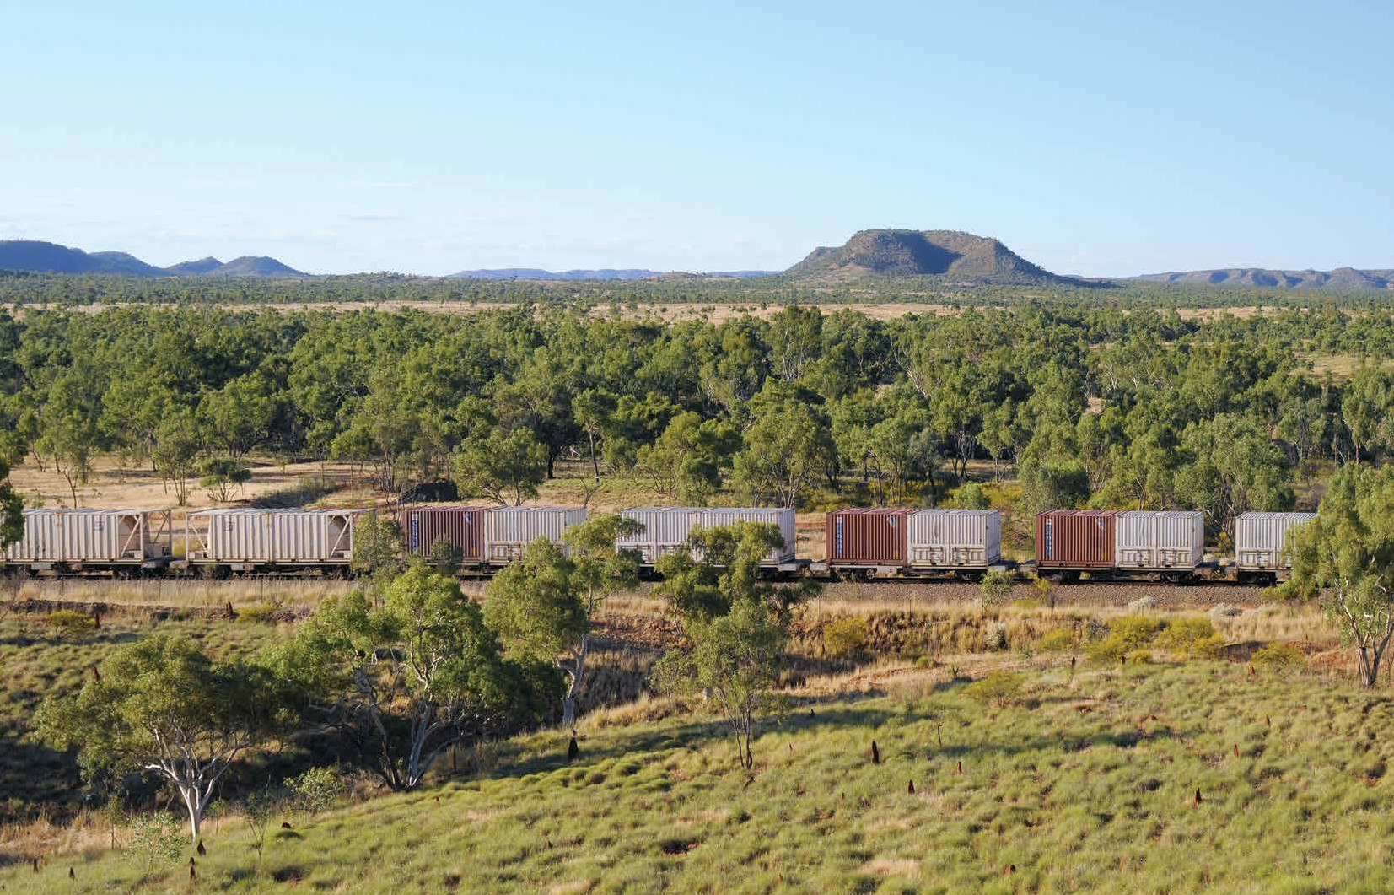

Working together

The system currently operates at high levels of asset utilisation for many components of the supply chain and there is potential for improvement through innovative supply chain operations and collaborative planning with all supply chain stakeholders.

Queensland Rail is focused on three key priorities with regards to the Mount Isa Line Supply Chain:

1. Maximising tonnage levels using current assets

2. Aligning asset capabilities with supply chain partners

3. Aligning capital investment with supply chain partners

The first priority concentrates on
short term operational improvements to increase tonnage levels using the current assets. Such operational improvements focus on:

• Reducing system variability

• Increasing planning disciplines

• Increasing system reliability
• Increasing communication to foster transparency and
aid decision making: In 2010, Queensland Rail introduced a regular supply chain forum for all stakeholders. These open forums are aimed at informing supply chain partners and stakeholders of planning activities, maintenance updates and other relevant information.

• Investigating differing operating models eg longer trains: Longer trains enable the same number of tonnes to be moved between any two points with fewer trains
and therefore potentially uses less network capacity. Queensland Rail will be working with rail operators to facilitate the operation of longer trains on the Mount Isa
Line to approximately 1000 metres in the first instance where possible.

The second supply chain priority aligns the capacity capabilities of assets in the medium term. This involves investigating the throughput of each supply chain facility – mine load out, rail, haulage operator, port unloading, shipping facilities.
• Ensure bottlenecks in system can maintain the required throughput

• Ensure asset capability through the system remains balanced.

The longer term priority is to align capital investments across the entire supply chain.

The implementation of more integrated planning across
the supply chain is a fantastic opportunity for Queensland Rail
and other supply chain stakeholders to realise the potential benefits
of operational efficiencies on the Mount Isa Line. Process improvements will encourage discipline in planning and execution throughout the supply chain from
all stakeholders.

17

A critical link

The Port of Townsville is a critical supply chain partner on the
Mount Isa Line and is the primary destination for the majority of products hauled on the line. Queensland Rail maintains and fosters a close working relationship with the Port of Townsville to develop and align capacity enhancement plans.

Together Queensland Rail and the
Port of Townsville are working to
create the optimum supply chain environment to meet the future needs of industry, unlocking the potential of the region.

Integrated planning is well advanced for the establishment of additional capacity and removal of supply chain bottlenecks.
Guided by the Port of Townsville Master Plan (2007), key initiatives being investigated include the establishment of Common User Facilities and infrastructure to
efficiently manage the export of coal through the Eastern Reclamation Area. This process will ensure that export trade through the Port of Townsville remains the key economic driver for Townsville; cementing Townsville’s position as northern Australia’s fastest growing economic region.

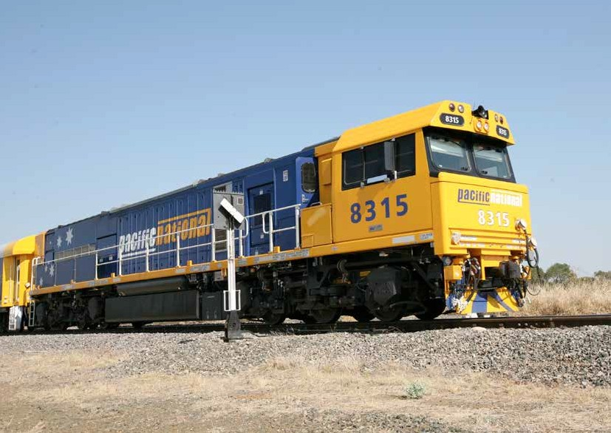

18

Providing options for our customers

The anticipated coal tonnages to be mined in the Galilee Basin adjoining the Mount Isa Line are significant, particularly when compared to the current traffic task. Queensland
Rail is therefore investigating all
options for customers in order to deliver the required coal tonnages to port. This includes the possibility of constructing a new rail line connecting the Mount Isa Line
in the vicinity of Charters Towers directly to the North Coast Line for access to Abbot Point.
This option may provide customers with greater economies of scale through the provision of direct access to the expanding deep water bulk commodity export port of Abbot Point.

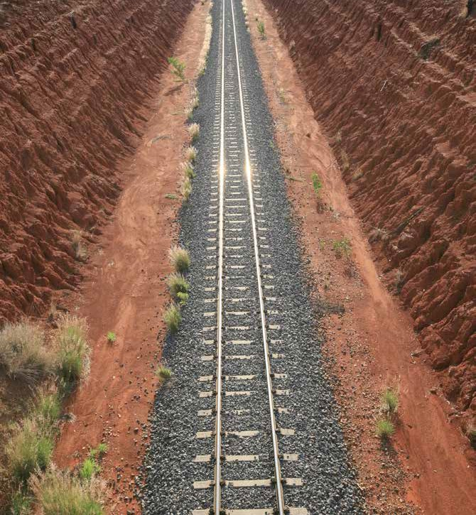
19

Innovative business solutions

Queensland Rail welcomes innovative and unique business models that
will facilitate tonnages to match the needs of our customers. Historically, Queensland Rail has funded, built, maintained and managed all rail assets. Moving forward, Queensland Rail is seeking to engage with new stakeholders in a variety of differing business solutions.

A number of different business models are currently being investigated for enabling assets along the corridor including:

• Assets owned and operated by the customer

• Assets owned and operated by a third party

• Multi user funding variations

• Multiple mining companies providing equity and jointly developing rail infrastructure

• Multiple third party equity providers developing rail infrastructure for mining companies

• Multiple third party equity providers developing rail infrastructure for multiple mining companies.

Some potential projects which are currently being scoped are:

• Townsville Eastern Access Corridor

• Common User Facility at the Port of Townsville
• Various load-out facilities along the corridor.

Eastern Access Corridor Should tonnages significantly increase, one major project which will be required is the Townsville Eastern Access Corridor. The Eastern Access Corridor is an 8km green
field rail line which if developed, would provide a dedicated rail corridor for the Mount Isa Line allowing uninterrupted access to the Port of Townsville. The project is in the vicinity of approximately $280 million with construction expected
to take two years once approvals are received.

The key objectives of the Eastern
Access Corridor are:

• Increase volumes transported on the Mount Isa Line through the Port of Townsville

• Improve efficiency with longer and faster trains

• Reduce bottlenecks in and around the Port of Townsville

• Improve urban amenity, including increasing safety and reducing traffic delays by diverting bulk freight transport away from busy Townsville suburbs.
Existing Rail Existing Rail Common Future Link Future Rail
TSDA
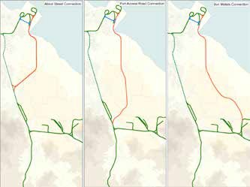

The Eastern Access Corridor becomes essential with tonnage levels beyond 10 mtpa due to the traffic congestion caused by a large number of trains servicing the
Port of Townsville across numerous level crossings within the Townsville City Centre. Queensland Rail is mindful of the negative impact
such traffic flows may have on the Townsville Community. All supply chain stakeholders are working collaboratively to determine the most suitable location for industry and the Townsville Community. Three potential options are illustrated above.

The Eastern Access Corridor, as part of the Mount Isa Line, was placed on the Infrastructure Australia Priority List in 2010
and was declared a nationally significant project in 2011. The project is currently in the Preliminary Evaluation stage of the Queensland State
Government’s Project Assurance Framework which is aimed at evaluating the economics of the project and delivery options.

20

Queensland Rail welcomes opportunities to work with customers with a view to transporting additional tonnages on the Mount Isa Line.

We encourage rail operators, mining companies and/or processors to engage with Queensland Rail at the earliest possible opportunity. This will allow sufficient time to work through detailed capacity analysis and to determine the network upgrades
necessary and negotiate appropriate
commercial arrangements.
Capacity enhancements will continue to be delivered for future projects provided that contracted tonnages:

• are sufficient to justify the necessary capital investment on commercial terms

• adequate notice is given from the time of contracting capacity to deliver the required enhancements.
We invite all current and prospective customers to discuss their access requirements with us.
We will continue to work closely with our customers to understand their individual markets and growth opportunities and we will be there to help grow and improve their business.

Our customers are our absolute priority.

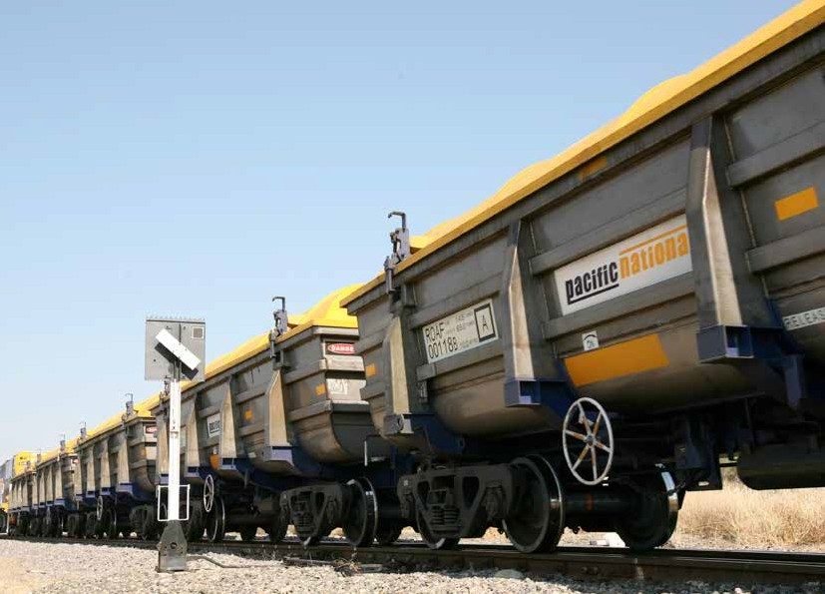

21

We’re here to help

Group General Manager Network Business

GPO Box 1429
Brisbane 4001

Phone: 07 3235 5325

General Manager Network Commercial

GPO Box 1429

Brisbane 4001

Phone: 07 3235 3609

General Manager Customer Service North

PO Box 1102

Townsville 4810

Phone: 07 4772 8872

22
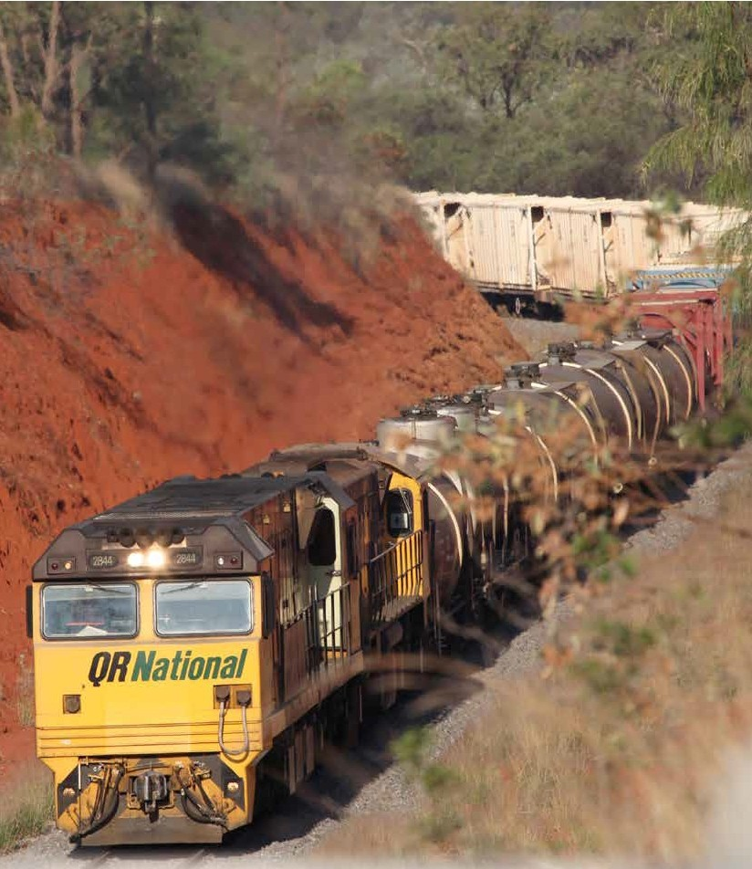

23

Queensland Rail Limited ABN 71 132 181 090_QR4159.1_A4_0812

